Table 1
Connections over 200 kbps in at Least One Direction 2009-2013
(In thousands)

 | 2009 |  | 2010 |  | 2011 |  | 2012 |  | 2013
Technology | Jun | Dec | Jun | Dec | Jun | Dec | Jun | Dec | Jun
Total | 119,433 | 136,294 | 157,017 | 182,065 | 206,131 | 230,201 | 243,359 | 261,389 | 275,608
Total Fixed | 77,997 | 79,994 | 81,764 | 84,521 | 86,575 | 88,317 | 89,945 | 92,514 | 94,243
Mobile Wireless¹ | 41,436 | 56,300 | 75,253 | 97,544 | 119,556 | 141,883 | 153,414 | 168,875 | 181,365

Table 2
Connections at Least 3 Mbps Downstream and 768 kbps Upstream 2009-2013
(In thousands)

 | 2009 |  | 2010 |  | 2011 |  | 2012 |  | 2013
Technology | Jun | Dec | Jun | Dec | Jun | Dec | Jun | Dec | Jun
Total | 33,332 | 40,669 | 45,552 | 55,110 | 64,819 | 82,015 | 100,268 | 128,448 | 163,730
Total Fixed | 33,108 | 38,963 | 41,364 | 44,694 | 48,577 | 51,097 | 57,243 | 64,572 | 70,483
Mobile Wireless¹ | 224 | 1,706 | 4,188 | 10,416 | 16,242 | 30,918 | 43,025 | 63,876 | 93,247

Table 3
Residential Connections over 200 kbps in at Least One Direction 2009-2013
(In thousands)

 | 2009 |  | 2010 |  | 2011 |  | 2012 |  | 2013
Technology | Jun | Dec | Jun | Dec | Jun | Dec | Jun | Dec | Jun
Total | 103,300 | 117,089 | 132,567 | 149,441 | 171,773 | 186,516 | 196,665 | 215,111 | 227,932
Total Fixed | 71,509 | 73,394 | 75,251 | 76,918 | 78,906 | 80,706 | 82,217 | 84,393 | 85,528
Mobile Wireless¹ | 31,791 | 43,695 | 57,316 | 72,523 | 92,867 | 105,810 | 114,448 | 130,719 | 142,404

Table 4
Residential Connections at Least 3 Mbps Downstream and 768 kbps Upstream 2009-2013
(In thousands)

 | 2009 |  | 2010 |  | 2011 |  | 2012 |  | 2013
Technology | Jun | Dec | Jun | Dec | Jun | Dec | Jun | Dec | Jun
Total | 31,356 | 38,426 | 42,243 | 47,632 | 51,783 | 63,736 | 78,609 | 105,171 | 137,056
Total Fixed | 31,161 | 36,844 | 39,037 | 41,769 | 45,263 | 47,427 | 53,070 | 59,828 | 65,041
Mobile Wireless¹ | 196 | 1,582 | 3,206 | 5,863 | 6,520 | 16,309 | 25,539 | 45,342 | 72,014

Note: Some historical data have been revised. Figures may not sum to totals due to rounding.
Source: FCC Form 477, Parts I and VI.

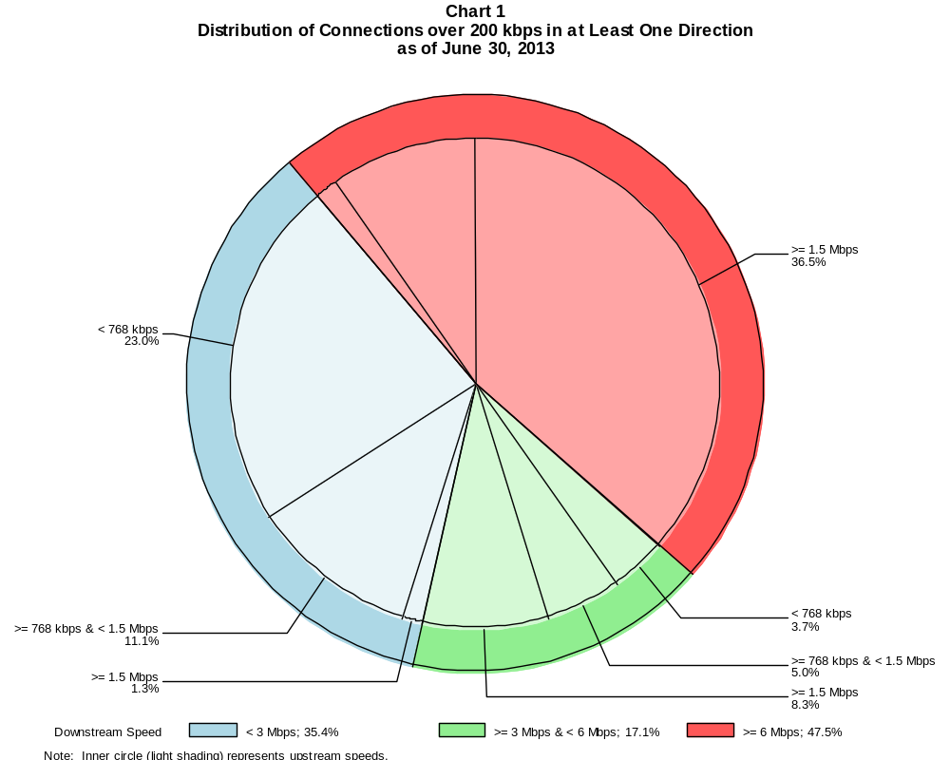

Connections over 200 kbps in at Least One Direction (in thousands)

 | Downstream Speed
Upstream Speed | Less than 3 Mbps | At least 3 Mbps  and less than 6 Mbps | At least 6 Mbps | Total
Less than 768 kbps | 63,390 | 10,301 | 4,061 | 77,751
At least 768 kbps & Less than 1.5 Mbps | 30,508 | 13,853 | 26,465 | 70,826
At least 1.5 Mbps | 3,619 | 22,907 | 100,505 | 127,030
Total | 97,516 | 47,061 | 131,031 | 275,608

Percentages

Less than 768 kbps | 23.0 | 3.7 | 1.5 | 28.2
At least 768 kbps & Less than 1.5 Mbps | 11.1 | 5.0 | 9.6 | 25.7
At least 1.5 Mbps | 1.3 | 8.3 | 36.5 | 46.1
Total | 35.4 | 17.1 | 47.5 | 100.0

Note: Figures may not sum to totals due to rounding.
Source: FCC Form 477, Part I.

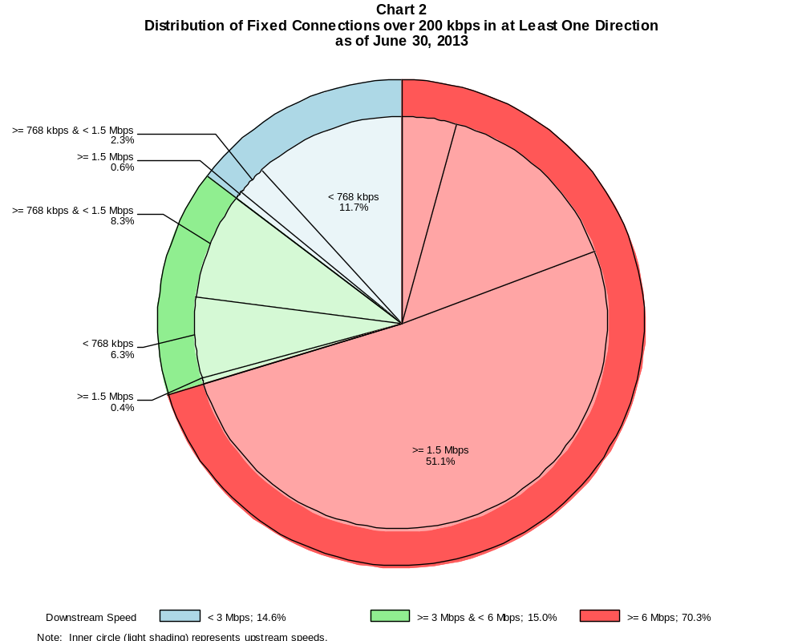

Fixed Connections over 200 kbps in at Least One Direction (in thousands)

 | Downstream Speed
Upstream Speed | Less than 3 Mbps | At least 3 Mbps  and less than 6 Mbps | At least 6 Mbps | Total
Less than 768 kbps | 11,057 | 5,946 | 4,031 | 21,034
At least 768 kbps & Less than 1.5 Mbps | 2,162 | 7,812 | 14,089 | 24,063
At least 1.5 Mbps | 564 | 415 | 48,168 | 49,146
Total | 13,784 | 14,172 | 66,287 | 94,243

Percentages

Less than 768 kbps | 11.7 | 6.3 | 4.3 | 22.3
At least 768 kbps & Less than 1.5 Mbps | 2.3 | 8.3 | 14.9 | 25.5
At least 1.5 Mbps | 0.6 | 0.4 | 51.1 | 52.1
Total | 14.6 | 15.0 | 70.3 | 100.0

Note: Figures may not sum to totals due to rounding.
Source: FCC Form 477, Part I.

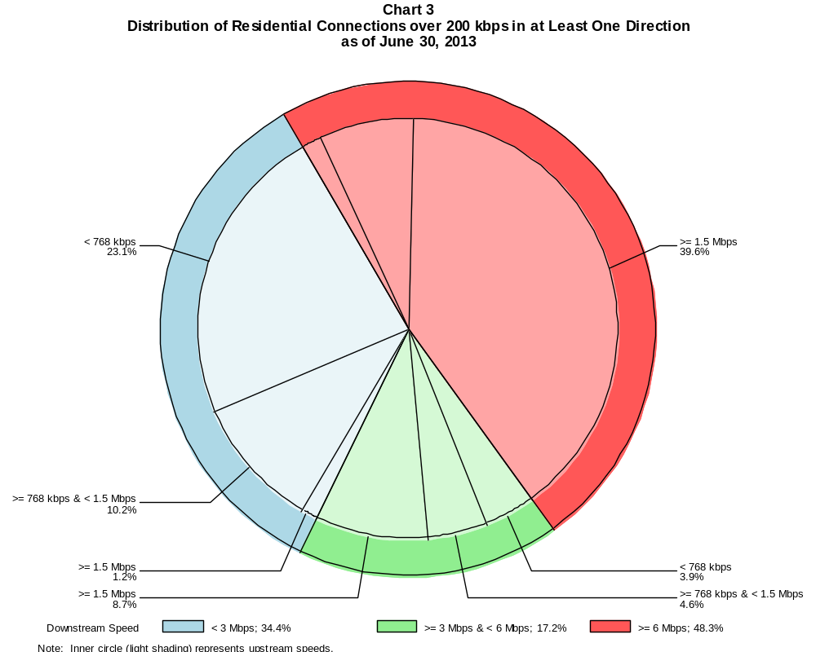

Residential Connections over 200 kbps in at Least One Direction (in thousands)

 | Downstream Speed
Upstream Speed | Less than 3 Mbps | At least 3 Mbps  and less than 6 Mbps | At least 6 Mbps | Total
Less than 768 kbps | 52,539 | 8,879 | 3,487 | 64,905
At least 768 kbps & Less than 1.5 Mbps | 23,184 | 10,549 | 16,453 | 50,186
At least 1.5 Mbps | 2,787 | 19,813 | 90,241 | 112,841
Total | 78,509 | 39,241 | 110,181 | 227,932

Percentages

Less than 768 kbps | 23.1 | 3.9 | 1.5 | 28.5
At least 768 kbps & Less than 1.5 Mbps | 10.2 | 4.6 | 7.2 | 22.0
At least 1.5 Mbps | 1.2 | 8.7 | 39.6 | 49.5
Total | 34.4 | 17.2 | 48.3 | 100.0

Note: Figures may not sum to totals due to rounding.
Source: FCC Form 477, Parts I and VI.

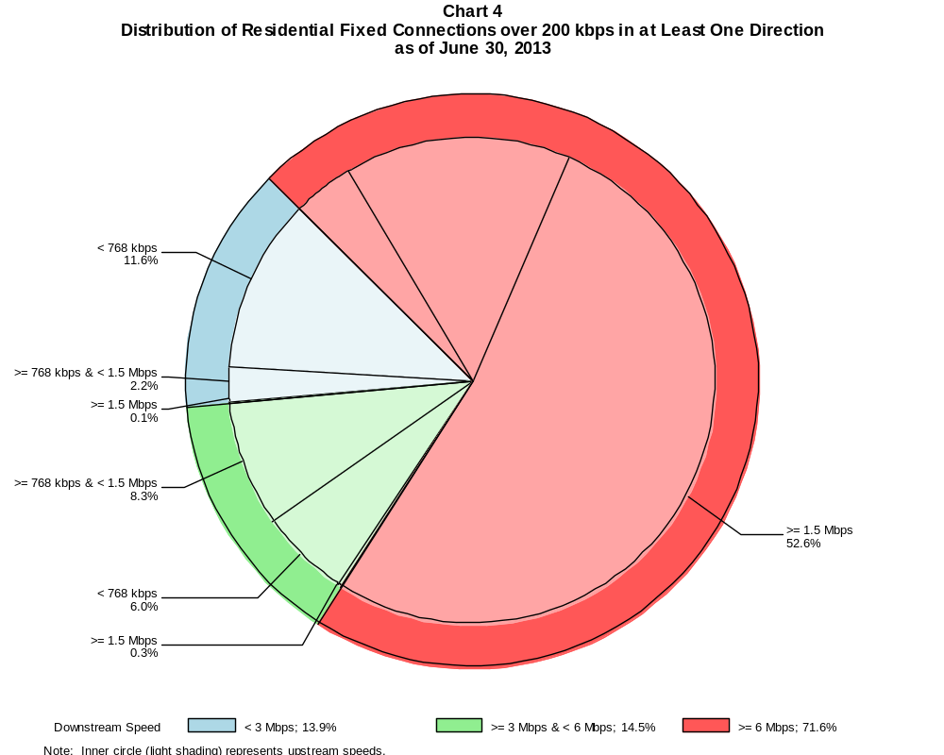

Residential Fixed Connections over 200 kbps in at Least One Direction (in thousands)

 | Downstream Speed
Upstream Speed | Less than 3 Mbps | At least 3 Mbps  and less than 6 Mbps | At least 6 Mbps | Total
Less than 768 kbps | 9,882 | 5,124 | 3,462 | 18,467
At least 768 kbps & Less than 1.5 Mbps | 1,921 | 7,058 | 12,732 | 21,711
At least 1.5 Mbps | 98 | 240 | 45,011 | 45,349
Total | 11,901 | 12,423 | 61,204 | 85,528

Percentages

Less than 768 kbps | 11.6 | 6.0 | 4.0 | 21.6
At least 768 kbps & Less than 1.5 Mbps | 2.2 | 8.3 | 14.9 | 25.4
At least 1.5 Mbps | 0.1 | 0.3 | 52.6 | 53.0
Total | 13.9 | 14.5 | 71.6 | 100.0

Note: Figures may not sum to totals due to rounding.
Source: FCC Form 477, Part VI.

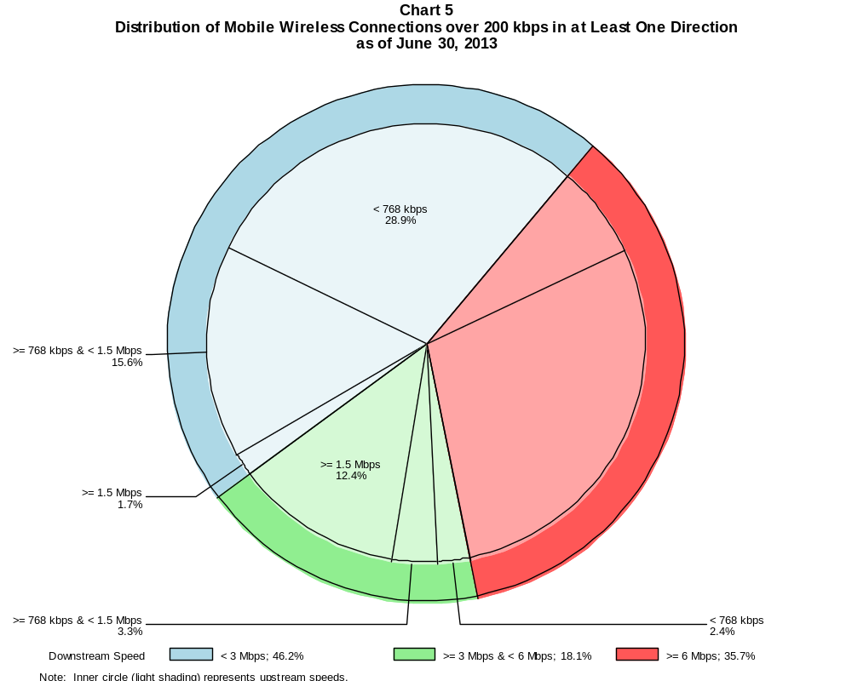

Mobile Wireless Connections over 200 kbps in at Least One Direction (in thousands)

 | Downstream Speed
Upstream Speed | Less than 3 Mbps | At least 3 Mbps  and less than 6 Mbps | At least 6 Mbps | Total
Less than 768 kbps | 52,332 | 4,355 | 30 | 56,717
At least 768 kbps & Less than 1.5 Mbps | 28,346 | 6,042 | 12,376 | 46,763
At least 1.5 Mbps | 3,055 | 22,492 | 52,337 | 77,884
Total | 83,732 | 32,889 | 64,743 | 181,365

Percentages

Less than 768 kbps | 28.9 | 2.4 | 0.0 | 31.3
At least 768 kbps & Less than 1.5 Mbps | 15.6 | 3.3 | 6.8 | 25.8
At least 1.5 Mbps | 1.7 | 12.4 | 28.9 | 42.9
Total | 46.2 | 18.1 | 35.7 | 100.0

Note: Figures may not sum to totals due to rounding.
Source: FCC Form 477, Part I.

Table 5
Connections over 200 kbps in at Least One Direction by Technology 2009-2013
(In thousands)

 | 2009 |  | 2010 |  | 2011 |  | 2012 |  | 2013
Technology | Jun | Dec | Jun | Dec | Jun | Dec | Jun | Dec | Jun
Total | 119,433 | 136,294 | 157,017 | 182,065 | 206,131 | 230,201 | 243,359 | 261,389 | 275,608
Total Fixed | 77,997 | 79,994 | 81,764 | 84,521 | 86,575 | 88,317 | 89,945 | 92,514 | 94,243
aDSL | 30,631 | 30,987 | 30,759 | 31,470 | 31,611 | 31,330 | 31,173 | 30,979 | 30,892
sDSL | 217 | 225 | 191 | 167 | 159 | 148 | 139 | 132 | 117
Other Wireline¹ | 689 | 719 | 755 | 795 | 778 | 795 | 770 | 798 | 780
Cable Modem | 41,434 | 42,439 | 43,923 | 45,334 | 46,698 | 48,263 | 49,664 | 51,646 | 52,760
FTTP² | 3,548 | 3,980 | 4,441 | 4,993 | 5,477 | 5,898 | 6,300 | 6,728 | 7,261
Satellite | 990 | 1,116 | 1,144 | 1,176 | 1,204 | 1,190 | 1,217 | 1,454 | 1,623
Fixed Wireless | 488 | 527 | 551 | 587 | 649 | 693 | 682 | 777 | 810
Mobile Wireless³ | 41,436 | 56,300 | 75,253 | 97,544 | 119,556 | 141,883 | 153,414 | 168,875 | 181,365

¹ Power Line and Other are summarized with Other Wireline to maintain firm confidentiality. See Technical Notes at the end of the report for a description of
Form 477 technology categories and other reporting requirements.
² Fiber to the premises.

Note: Some historical data have been revised. Figures may not sum to totals due to rounding.
Source: FCC Form 477, Part I.

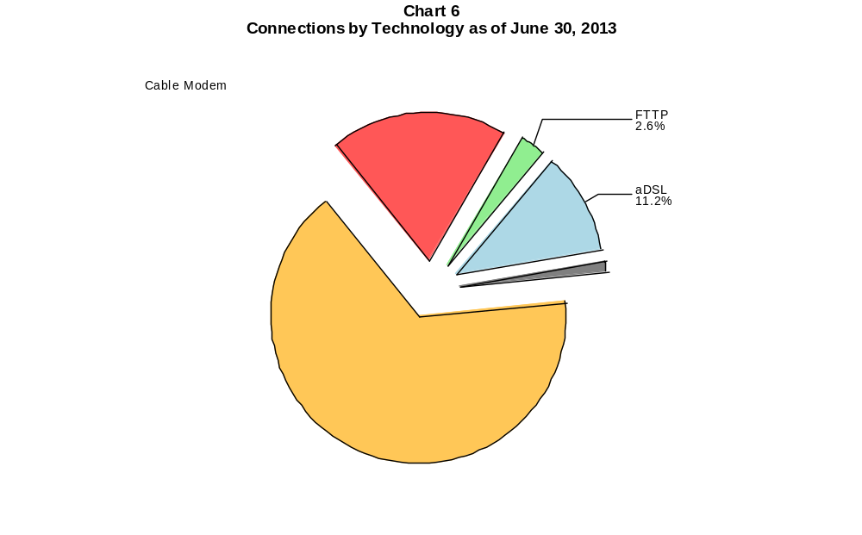

Table 6
Residential Connections over 200 kbps in at Least One Direction by Technology 2009-2013
(In thousands)

 | 2009 |  | 2010 |  | 2011 |  | 2012 |  | 2013
Technology | Jun | Dec | Jun | Dec | Jun | Dec | Jun | Dec | Jun
Total | 103,300 | 117,089 | 132,567 | 149,441 | 171,773 | 186,516 | 196,665 | 215,111 | 227,932
Total Fixed | 71,509 | 73,394 | 75,251 | 76,918 | 78,906 | 80,706 | 82,217 | 84,393 | 85,528
aDSL | 27,047 | 27,402 | 27,488 | 27,467 | 27,754 | 27,758 | 27,632 | 27,397 | 27,103
sDSL | 71 | 85 | 65 | 53 | 52 | 54 | 49 | 50 | 43
Other Wireline¹ | 49 | 56 | 61 | 76 | 45 | 40 | 14 | 34 | 28
Cable Modem | 39,909 | 40,872 | 42,178 | 43,295 | 44,480 | 45,832 | 47,033 | 48,716 | 49,494
FTTP² | 3,348 | 3,758 | 4,185 | 4,704 | 5,118 | 5,521 | 5,892 | 6,264 | 6,743
Satellite | 668 | 767 | 787 | 811 | 885 | 886 | 998 | 1,242 | 1,407
Fixed Wireless | 417 | 454 | 486 | 513 | 572 | 616 | 600 | 689 | 710
Mobile Wireless³ | 31,791 | 43,695 | 57,316 | 72,523 | 92,867 | 105,810 | 114,448 | 130,719 | 142,404

¹ Power Line and Other are summarized with Other Wireline to maintain firm confidentiality. See Technical Notes at the end of the report for a description of
Form 477 technology categories and other reporting requirements.
² Fiber to the premises.

Note: Some historical data have been revised. Figures may not sum to totals due to rounding.
Source: FCC Form 477, Part I.

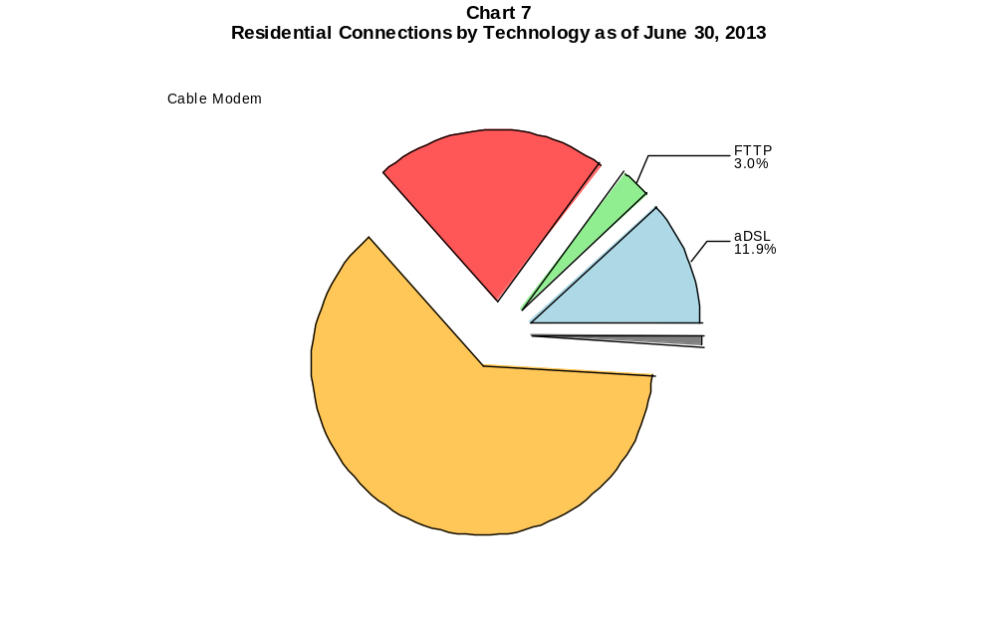

Table 7
Connections at Least 3 Mbps Downstream and 768 kbps Upstream by Technology 2009-2013
(In thousands)

 | 2009 |  | 2010 |  | 2011 |  | 2012 |  | 2013
Technology | Jun | Dec | Jun | Dec | Jun | Dec | Jun | Dec | Jun
Total | 33,332 | 40,669 | 45,552 | 55,110 | 64,819 | 82,015 | 100,268 | 128,448 | 163,730
Total Fixed | 33,108 | 38,963 | 41,364 | 44,694 | 48,577 | 51,097 | 57,243 | 64,572 | 70,483
aDSL | 5,614 | 6,389 | 6,275 | 7,302 | 8,909 | 10,351 | 12,875 | 13,028 | 16,029
sDSL | 9 | 19 | 13 | 14 | 16 | 26 | 30 | 33 | 34
Other Wireline¹ | 129 | 150 | 177 | 211 | 204 | 228 | 239 | 276 | 289
Cable Modem | 23,958 | 28,583 | 30,616 | 32,338 | 34,113 | 34,699 | 37,798 | 44,133 | 46,014
FTTP² | 3,333 | 3,739 | 4,192 | 4,725 | 5,188 | 5,606 | 6,001 | 6,425 | 6,989
Satellite | # | # | # | # | # | # | 87 | 394 | 791
Fixed Wireless | 64 | 82 | 92 | 105 | 145 | 186 | 214 | 284 | 337
Mobile Wireless | 224 | 1,706 | 4,188 | 10,416 | 16,242 | 30,918 | 43,025 | 63,876 | 93,247

# = Rounds to Zero.
¹ Power Line and Other are summarized with Other Wireline to maintain firm confidentiality. See Technical Notes at the end of the report for a description of
Form 477 technology categories and other reporting requirements.
² Fiber to the premises.
Note: Some historical data have been revised. Figures may not sum to totals due to rounding.
Source: FCC Form 477, Part I.

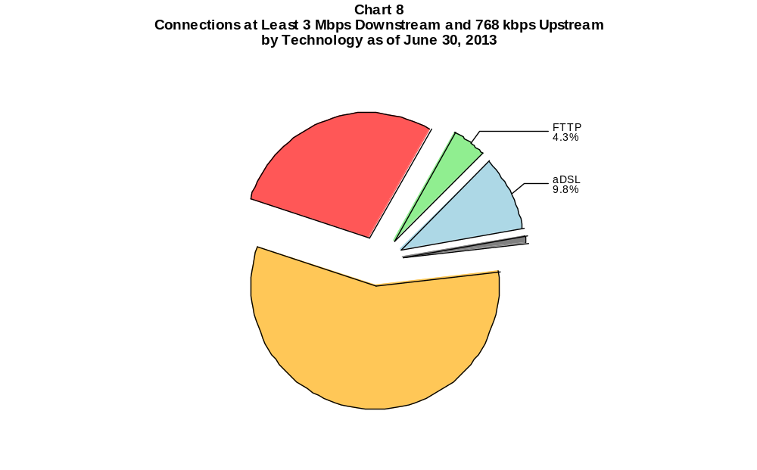

Table 8
Residential Connections at Least 3 Mbps Downstream and 768 kbps Upstream by Technology 2009-2013
(In thousands)

 | 2009 |  | 2010 |  | 2011 |  | 2012 |  | 2013
Technology | Jun | Dec | Jun | Dec | Jun | Dec | Jun | Dec | Jun
Total | 31,356 | 38,426 | 42,243 | 47,632 | 51,783 | 63,736 | 78,609 | 105,171 | 137,056
Total Fixed | 31,161 | 36,844 | 39,037 | 41,769 | 45,263 | 47,427 | 53,070 | 59,828 | 65,041
aDSL | 4,895 | 5,633 | 5,557 | 6,421 | 7,909 | 9,274 | 11,563 | 11,588 | 14,353
sDSL | 2 | 10 | 2 | 2 | 4 | 12 | 12 | 13 | 13
Other Wireline¹ | 12 | 19 | 20 | 36 | 15 | 16 | 7 | 20 | 26
Cable Modem | 23,025 | 27,548 | 29,398 | 30,742 | 32,321 | 32,693 | 35,583 | 41,561 | 43,061
FTTP² | 3,177 | 3,566 | 3,982 | 4,482 | 4,894 | 5,271 | 5,632 | 6,007 | 6,512
Satellite | 0 | 0 | 0 | 0 | 0 | # | 86 | 393 | 788
Fixed Wireless | 50 | 68 | 77 | 86 | 121 | 161 | 185 | 245 | 289
Mobile Wireless | 196 | 1,582 | 3,206 | 5,863 | 6,520 | 16,309 | 25,539 | 45,342 | 72,014

# = Rounds to Zero.
¹ Power Line and Other are summarized with Other Wireline to maintain firm confidentiality. See Technical Notes at the end of the report for a description of
Form 477 technology categories and other reporting requirements.
² Fiber to the premises.
Note: Some historical data have been revised. Figures may not sum to totals due to rounding.
Source: FCC Form 477, Part I.

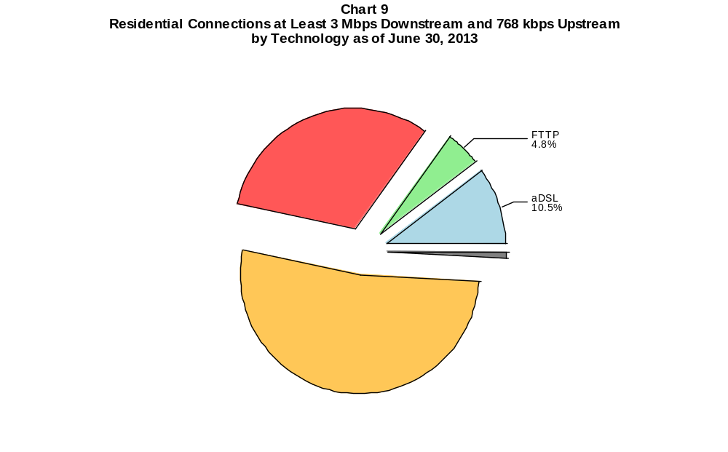

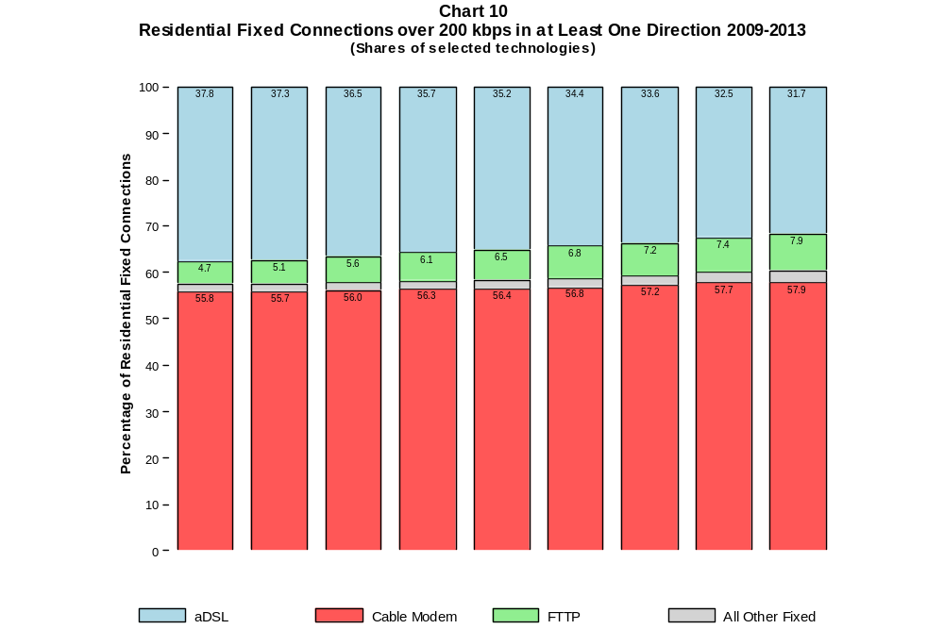

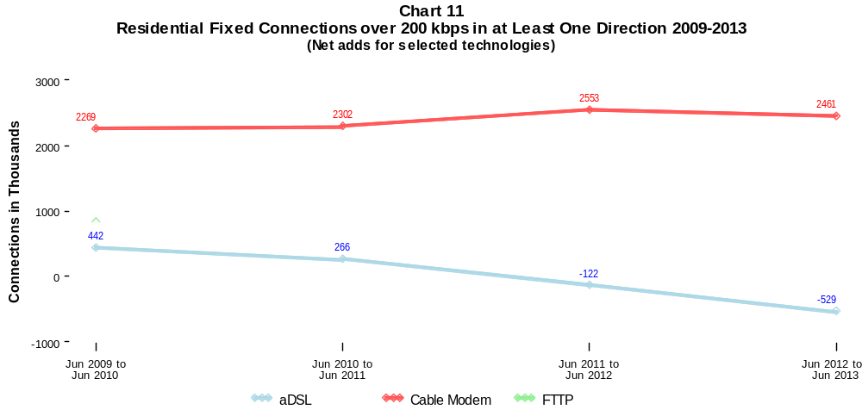

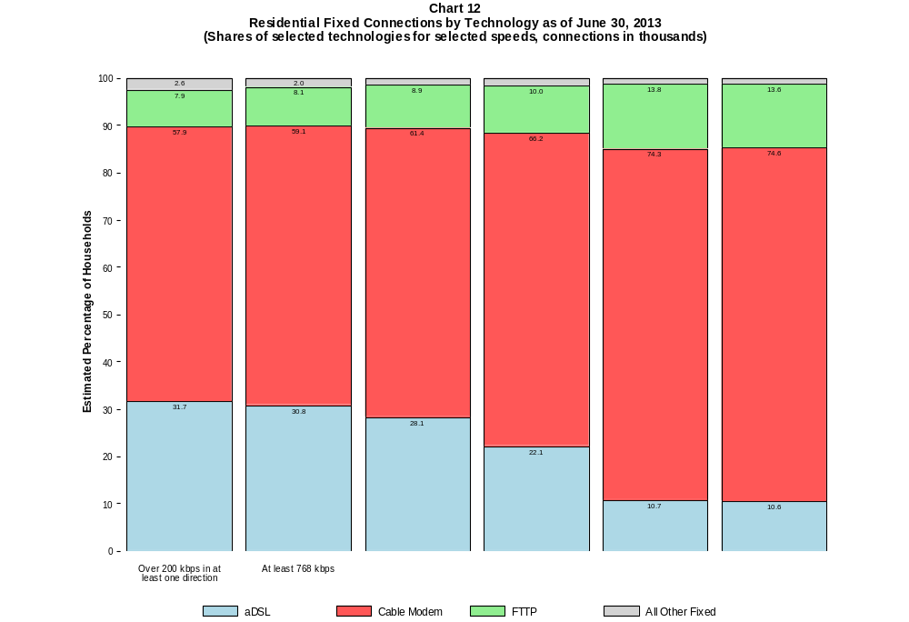

Table 9
Residential Connections by Technology and Speed (BTOP/BIP Definition)
as of June 30, 2013
(In thousands)

Technology | At Most  200 kbps  Upstream or  less than  768 kbps  Downstream | Over  200 kbps  Upstream and  at least  768 kbps  Downstream | Total
aDSL | 1,397 | 25,706 | 27,103
sDSL | 8 | 35 | 43
Other Wireline | # | 28 | 28
Cable Modem | 146 | 49,348 | 49,494
FTTP | 11 | 6,732 | 6,743
Satellite | 443 | 964 | 1,407
Fixed Wireless | 80 | 630 | 710
Mobile Wireless | 29,631 | 112,772 | 142,404
Total | 31,716 | 196,216 | 227,932

# = Rounds to Zero. Power Line and Other are combined with Other Wireline to maintain firm confidentiality.
Note: Figures may not sum to totals due to rounding.
Source: FCC Form 477, Parts I and VI.

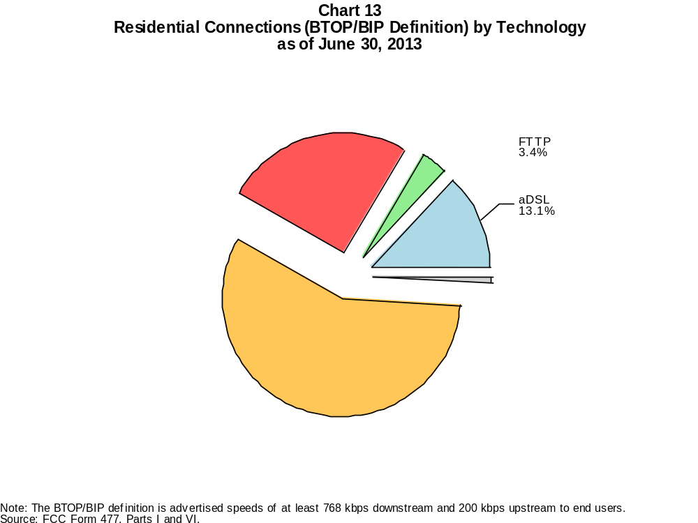

Table 10
Connections by Downstream Speed Tier and Technology as of June 30, 2013
(In thousands)

 | Downstream Speed
Technology | Greater than 200  kbps and less than  768 kbps | At least 768 kbps  and less than  1.5 Mbps | At least 1.5 Mbps  and less than  3 Mbps | At least 3 Mbps  and less than  6 Mbps | At least 6 Mbps  and less than  10 Mbps | At least 10 Mbps  and less than  25 Mbps | At least 25 Mbps  and less than  100 Mbps | At least 100 Mbps | Total
aDSL | 454 | 2,859 | 4,023 | 9,232 | 6,632 | 7,524 | 168 | # | 30,892
sDSL | 25 | 37 | 21 | * | * | * | * | * | 117
Other Wireline | 38 | 43 | 410 | 114 | 29 | 66 | 48 | 32 | 780
Cable Modem | 134 | 1,003 | 3,271 | 4,106 | 1,510 | 22,920 | 19,644 | 172 | 52,760
FTTP | 13 | 89 | 102 | 272 | 197 | 4,080 | 2,407 | 101 | 7,261
Satellite | 233 | 372 | 218 | * | * | * | 0 | 0 | 1,623
Fixed Wireless | 73 | 137 | 227 | 248 | 65 | 56 | 2 | 1 | 810
Mobile Wireless | 36,257 | 4,570 | 42,905 | 32,889 | 19,797 | 38,198 | * | * | 181,365
Total | 37,227 | 9,113 | 51,177 | 47,061 | 28,233 | 73,469 | 29,021 | 307 | 275,608

Percentages

aDSL | 0.2 | 1.0 | 1.5 | 3.3 | 2.4 | 2.7 | 0.1 | 0.0 | 11.2
sDSL | 0.0 | 0.0 | 0.0 | * | * | * | * | * | 0.0
Other Wireline | 0.0 | 0.0 | 0.1 | 0.0 | 0.0 | 0.0 | 0.0 | 0.0 | 0.3
Cable Modem | 0.0 | 0.4 | 1.2 | 1.5 | 0.5 | 8.3 | 7.1 | 0.1 | 19.1
FTTP | 0.0 | 0.0 | 0.0 | 0.1 | 0.1 | 1.5 | 0.9 | 0.0 | 2.6
Satellite | 0.1 | 0.1 | 0.1 | * | * | * | 0.0 | 0.0 | 0.6
Fixed Wireless | 0.0 | 0.0 | 0.1 | 0.1 | 0.0 | 0.0 | 0.0 | 0.0 | 0.3
Mobile Wireless | 13.2 | 1.7 | 15.6 | 11.9 | 7.2 | 13.9 | * | * | 65.8
Total | 13.5 | 3.3 | 18.6 | 17.1 | 10.2 | 26.7 | 10.5 | 0.1 | 100.0

# = Rounds to Zero. Power Line and Other are combined with Other Wireline to maintain firm confidentiality.
* = Data withheld to maintain firm confidentiality.
Note: Figures may not sum to totals due to rounding.
Source: FCC Form 477, Part I.

Table 11
Residential Connections by Downstream Speed Tier and Technology as of June 30, 2013
(In thousands)

 | Downstream Speed
Technology | Greater than 200  kbps and less than  768 kbps | At least 768 kbps  and less than  1.5 Mbps | At least 1.5 Mbps  and less than  3 Mbps | At least 3 Mbps  and less than  6 Mbps | At least 6 Mbps  and less than  10 Mbps | At least 10 Mbps  and less than  25 Mbps | At least 25 Mbps  and less than  100 Mbps | At least 100 Mbps | Total
aDSL | 397 | 2,679 | 3,312 | 7,949 | 5,560 | 7,049 | 157 | # | 27,103
sDSL | 8 | 19 | 3 | * | * | * | * | * | 43
Other Wireline | # | 1 | 2 | 4 | 3 | 15 | 2 | 2 | 28
Cable Modem | 119 | 985 | 3,204 | 3,834 | 1,125 | 21,162 | 18,924 | 140 | 49,494
FTTP | 10 | 82 | 76 | 238 | 180 | 3,851 | 2,262 | 44 | 6,743
Satellite | 102 | 331 | 181 | * | * | * | 0 | 0 | 1,407
Fixed Wireless | 67 | 121 | 201 | 216 | 55 | 49 | 1 | # | 710
Mobile Wireless | 28,553 | 4,269 | 33,787 | 26,818 | 10,602 | 32,225 | * | * | 142,404
Total | 29,257 | 8,487 | 40,766 | 39,241 | 17,527 | 64,971 | 27,499 | 185 | 227,932

Percentages

aDSL | 0.2 | 1.2 | 1.5 | 3.5 | 2.4 | 3.1 | 0.1 | 0.0 | 11.9
sDSL | 0.0 | 0.0 | 0.0 | * | * | * | * | * | 0.0
Other Wireline | 0.0 | 0.0 | 0.0 | 0.0 | 0.0 | 0.0 | 0.0 | 0.0 | 0.0
Cable Modem | 0.1 | 0.4 | 1.4 | 1.7 | 0.5 | 9.3 | 8.3 | 0.1 | 21.7
FTTP | 0.0 | 0.0 | 0.0 | 0.1 | 0.1 | 1.7 | 1.0 | 0.0 | 3.0
Satellite | 0.0 | 0.1 | 0.1 | * | * | * | 0.0 | 0.0 | 0.6
Fixed Wireless | 0.0 | 0.1 | 0.1 | 0.1 | 0.0 | 0.0 | 0.0 | 0.0 | 0.3
Mobile Wireless | 12.5 | 1.9 | 14.8 | 11.8 | 4.7 | 14.1 | * | * | 62.5
Total | 12.8 | 3.7 | 17.9 | 17.2 | 7.7 | 28.5 | 12.1 | 0.1 | 100.0

# = Rounds to Zero. Power Line and Other are combined with Other Wireline to maintain firm confidentiality.
* = Data withheld to maintain firm confidentiality.
Note: Figures may not sum to totals due to rounding.
Source: FCC Form 477, Part I.

Table 12
Nationwide Number of Providers of Connections over 200 kbps in at Least One Direction
by Technology 2009-2013

 | 2009 |  | 2010 |  | 2011 |  | 2012 |  | 2013
Technology | Jun | Dec | Jun | Dec | Jun | Dec | Jun | Dec | Jun
aDSL | 876 | 862 | 875 | 865 | 867 | 867 | 860 | 865 | 852
sDSL | 257 | 261 | 251 | 247 | 252 | 255 | 251 | 255 | 246
Other Wireline | 283 | 274 | 267 | 270 | 265 | 274 | 258 | 262 | 246
Cable Modem | 351 | 345 | 345 | 357 | 400 | 405 | 401 | 404 | 403
FTTP | 462 | 485 | 510 | 545 | 579 | 621 | 642 | 665 | 691
Satellite | 4 | 4 | 4 | 4 | 5 | 6 | 5 | 6 | 5
Fixed Wireless | 621 | 607 | 625 | 646 | 672 | 713 | 713 | 765 | 771
Mobile Wireless | 48 | 51 | 55 | 57 | 64 | 69 | 67 | 70 | 79
Power Line and Other | 6 | 6 | 5 | 7 | 4 | 5 | * | * | 0
Total | 1,551 | 1,526 | 1,536 | 1,566 | 1,624 | 1,687 | 1,673 | 1,722 | 1,714

Note: Some historical data have been revised. Multiple Form 477 filers within a holding company structure count as one provider. * = 1-3 providers.
Source: FCC Form 477, Part I.

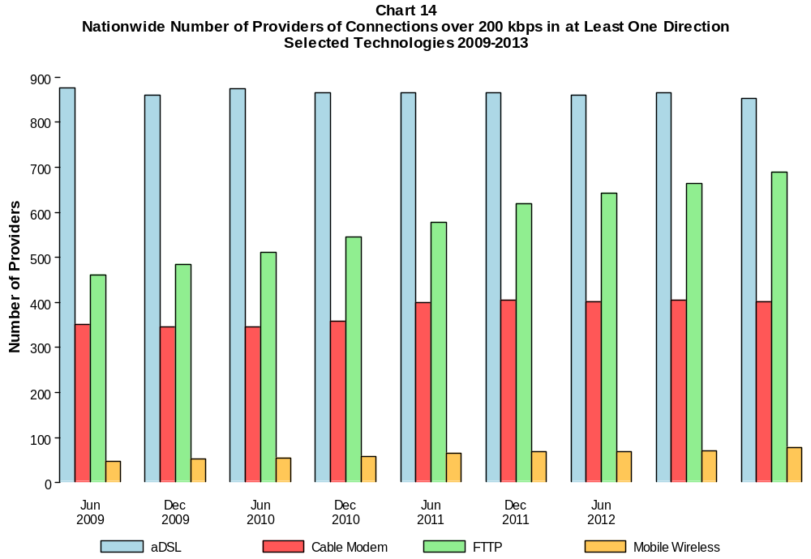

Table 13
Residential Fixed Connections at Least 3 Mbps Downstream / 768 kbps Upstream
and Households by State as of June 30, 2013
(Connections and households, in thousands)
State | Connections | Households | Subscribership  Ratio
Alabama | 715 | 1,907 | 0.38
Alaska | 108 | 266 | 0.41
American Samoa | 0 | 10 | 0.00
Arizona | 1,391 | 2,457 | 0.57
Arkansas | 403 | 1,165 | 0.35
California | 6,810 | 12,812 | 0.53
Colorado | 1,352 | 2,029 | 0.67
Connecticut | 913 | 1,381 | 0.66
Delaware | 255 | 351 | 0.73
District of Columbia | 194 | 274 | 0.71
Florida | 4,391 | 7,631 | 0.58
Georgia | 1,821 | 3,688 | 0.49
Guam | * | 42 | *
Hawaii | * | 465 | *
Idaho | 208 | 596 | 0.35
Illinois | 2,539 | 4,863 | 0.52
Indiana | 1,141 | 2,529 | 0.45
Iowa | 362 | 1,231 | 0.29
Kansas | 551 | 1,124 | 0.49
Kentucky | 826 | 1,742 | 0.47
Louisiana | 675 | 1,742 | 0.39
Maine | 374 | 559 | 0.67
Maryland | 1,573 | 2,194 | 0.72
Massachusetts | 2,036 | 2,567 | 0.79
Michigan | 2,069 | 3,861 | 0.54
Minnesota | 1,101 | 2,115 | 0.52
Mississippi | 307 | 1,123 | 0.27
Missouri | 1,041 | 2,400 | 0.43
Montana | 185 | 417 | 0.44
Nebraska | 354 | 730 | 0.48
Nevada | 568 | 1,045 | 0.54
New Hampshire | 397 | 523 | 0.76
New Jersey | 2,542 | 3,238 | 0.79
New Mexico | 349 | 809 | 0.43
New York | 4,677 | 7,350 | 0.64
North Carolina | 2,130 | 3,855 | 0.55
North Dakota | 156 | 286 | 0.54
Northern Mariana Isl | * | 16 | *
Ohio | 2,456 | 4,609 | 0.53
Oklahoma | 588 | 1,486 | 0.40
Oregon | 915 | 1,551 | 0.59
Pennsylvania | 3,156 | 5,046 | 0.63
Puerto Rico | 219 | 1,218 | 0.18
Rhode Island | 304 | 413 | 0.74
South Carolina | 937 | 1,848 | 0.51
South Dakota | 186 | 328 | 0.57
Tennessee | 1,177 | 2,542 | 0.46
Texas | 4,123 | 9,241 | 0.45
Utah | 563 | 909 | 0.62
Vermont | 174 | 257 | 0.68
Virgin Islands | 2 | 43 | 0.04
Virginia | 2,003 | 3,124 | 0.64
Washington | 1,763 | 2,691 | 0.66
West Virginia | 272 | 766 | 0.36
Wisconsin | 1,183 | 2,302 | 0.51
Wyoming | 114 | 232 | 0.49
Total | 65,041 | 119,999 | 0.54

# = Rounds to Zero; * = Data withheld to maintain firm confidentiality.
Note: Figures may not sum to totals due to rounding.
Sources: FCC Form 477, Part VI (Connections); Geolytics 2012 Block-Level Estimates (Households for U.S. and District of Columbia);
Census 2010 (Housing Units for Puerto Rico, American Samoa, Guam, Northern Mariana Islands and U.S. Virgin Islands).

Table 14
Residential Fixed Connections and Households by State as of June 30, 2013
(Connections over 200 kbps in at least one direction and households, in thousands)

State | Connections | Households | Subscribership  Ratio
Alabama | 1,139 | 1,907 | 0.60
Alaska | 181 | 266 | 0.68
American Samoa | * | 10 | *
Arizona | 1,751 | 2,457 | 0.71
Arkansas | 651 | 1,165 | 0.56
California | 9,800 | 12,812 | 0.76
Colorado | 1,588 | 2,029 | 0.78
Connecticut | 1,090 | 1,381 | 0.79
Delaware | 283 | 351 | 0.81
District of Columbia | 209 | 274 | 0.76
Florida | 5,695 | 7,631 | 0.75
Georgia | 2,513 | 3,688 | 0.68
Guam | * | 42 | *
Hawaii | 383 | 465 | 0.82
Idaho | 398 | 596 | 0.67
Illinois | 3,366 | 4,863 | 0.69
Indiana | 1,655 | 2,529 | 0.65
Iowa | 835 | 1,231 | 0.68
Kansas | 779 | 1,124 | 0.69
Kentucky | 1,137 | 1,742 | 0.65
Louisiana | 1,093 | 1,742 | 0.63
Maine | 431 | 559 | 0.77
Maryland | 1,681 | 2,194 | 0.77
Massachusetts | 2,135 | 2,567 | 0.83
Michigan | 2,602 | 3,861 | 0.67
Minnesota | 1,514 | 2,115 | 0.72
Mississippi | 576 | 1,123 | 0.51
Missouri | 1,526 | 2,400 | 0.64
Montana | 282 | 417 | 0.68
Nebraska | 512 | 730 | 0.70
Nevada | 719 | 1,045 | 0.69
New Hampshire | 439 | 523 | 0.84
New Jersey | 2,689 | 3,238 | 0.83
New Mexico | 491 | 809 | 0.61
New York | 5,870 | 7,350 | 0.80
North Carolina | 2,838 | 3,855 | 0.74
North Dakota | 209 | 286 | 0.73
Northern Mariana Isl | * | 16 | *
Ohio | 3,162 | 4,609 | 0.69
Oklahoma | 882 | 1,486 | 0.59
Oregon | 1,118 | 1,551 | 0.72
Pennsylvania | 3,741 | 5,046 | 0.74
Puerto Rico | 553 | 1,218 | 0.45
Rhode Island | 318 | 413 | 0.77
South Carolina | 1,265 | 1,848 | 0.68
South Dakota | 227 | 328 | 0.69
Tennessee | 1,550 | 2,542 | 0.61
Texas | 6,229 | 9,241 | 0.67
Utah | 686 | 909 | 0.75
Vermont | 204 | 257 | 0.79
Virgin Islands | 17 | 43 | 0.39
Virginia | 2,234 | 3,124 | 0.72
Washington | 2,026 | 2,691 | 0.75
West Virginia | 479 | 766 | 0.63
Wisconsin | 1,581 | 2,302 | 0.69
Wyoming | 158 | 232 | 0.68
Total | 85,528 | 119,999 | 0.71

# = Rounds to Zero; * = Data withheld to maintain firm confidentiality.
Note: Figures may not sum to totals due to rounding.
Sources: FCC Form 477, Part VI (Connections); Geolytics 2012 Block-Level Estimates (Households for U.S. and District of Columbia);
Census 2010 (Housing Units for Puerto Rico, American Samoa, Guam, Northern Mariana Islands and U.S. Virgin Islands).

Table 15
Connections by Type of End User by State as of June 30, 2013
(Connections over 200 kbps in at least one direction, in thousands)

 | Connections |  | Percentages
State | Residential | Business | Residential | Business | Total
Alabama | 3,140 | 432 | 87.9 | 12.1 | 3,573
Alaska | 546 | 97 | 85.0 | 15.0 | 643
American Samoa | * | * | * | * | *
Arizona | 4,430 | 732 | 85.8 | 14.2 | 5,162
Arkansas | 1,916 | 300 | 86.5 | 13.5 | 2,216
California | 27,800 | 6,283 | 81.6 | 18.4 | 34,083
Colorado | 5,387 | 1,088 | 83.2 | 16.8 | 6,475
Connecticut | 2,793 | 585 | 82.7 | 17.3 | 3,378
Delaware | 706 | 138 | 83.6 | 16.4 | 844
District of Columbia | 645 | 576 | 52.8 | 47.2 | 1,221
Florida | 14,536 | 3,229 | 81.8 | 18.2 | 17,765
Georgia | 7,088 | 1,390 | 83.6 | 16.4 | 8,479
Guam | 58 | 14 | 80.8 | 19.2 | 72
Hawaii | 1,088 | 176 | 86.0 | 14.0 | 1,264
Idaho | 1,055 | 200 | 84.1 | 15.9 | 1,255
Illinois | 9,203 | 2,097 | 81.4 | 18.6 | 11,300
Indiana | 4,259 | 704 | 85.8 | 14.2 | 4,962
Iowa | 1,990 | 353 | 84.9 | 15.1 | 2,343
Kansas | 1,889 | 553 | 77.3 | 22.7 | 2,442
Kentucky | 2,892 | 492 | 85.5 | 14.5 | 3,384
Louisiana | 3,344 | 508 | 86.8 | 13.2 | 3,852
Maine | 876 | 140 | 86.3 | 13.7 | 1,016
Maryland | 4,510 | 877 | 83.7 | 16.3 | 5,387
Massachusetts | 5,230 | 1,073 | 83.0 | 17.0 | 6,303
Michigan | 6,498 | 1,731 | 79.0 | 21.0 | 8,229
Minnesota | 3,703 | 909 | 80.3 | 19.7 | 4,613
Mississippi | 1,916 | 207 | 90.3 | 9.7 | 2,123
Missouri | 3,947 | 939 | 80.8 | 19.2 | 4,886
Montana | 695 | 97 | 87.7 | 12.3 | 792
Nebraska | 1,199 | 289 | 80.6 | 19.4 | 1,488
Nevada | 2,080 | 375 | 84.7 | 15.3 | 2,454
New Hampshire | 981 | 162 | 85.9 | 14.1 | 1,143
New Jersey | 7,204 | 1,491 | 82.9 | 17.1 | 8,695
New Mexico | 1,289 | 208 | 86.1 | 13.9 | 1,496
New York | 15,102 | 3,192 | 82.5 | 17.5 | 18,294
North Carolina | 6,625 | 1,343 | 83.1 | 16.9 | 7,968
North Dakota | 532 | 99 | 84.3 | 15.7 | 631
Northern Mariana Isl | * | * | * | * | *
Ohio | 7,911 | 1,682 | 82.5 | 17.5 | 9,593
Oklahoma | 2,568 | 430 | 85.7 | 14.3 | 2,998
Oregon | 2,827 | 544 | 83.9 | 16.1 | 3,371
Pennsylvania | 9,138 | 1,681 | 84.5 | 15.5 | 10,819
Puerto Rico | 2,058 | 204 | 91.0 | 9.0 | 2,261
Rhode Island | 766 | 151 | 83.5 | 16.5 | 917
South Carolina | 3,024 | 453 | 87.0 | 13.0 | 3,477
South Dakota | 557 | 80 | 87.4 | 12.6 | 638
Tennessee | 4,311 | 851 | 83.5 | 16.5 | 5,161
Texas | 19,099 | 4,513 | 80.9 | 19.1 | 23,612
Utah | 1,839 | 416 | 81.5 | 18.5 | 2,256
Vermont | 427 | 78 | 84.5 | 15.5 | 505
Virgin Islands | 73 | 14 | 83.4 | 16.6 | 87
Virginia | 5,913 | 1,331 | 81.6 | 18.4 | 7,244
Washington | 5,108 | 1,167 | 81.4 | 18.6 | 6,275
West Virginia | 1,117 | 154 | 87.9 | 12.1 | 1,271
Wisconsin | 3,631 | 782 | 82.3 | 17.7 | 4,413
Wyoming | 405 | 63 | 86.6 | 13.4 | 468
Total | 227,932 | 47,676 | 82.7 | 17.3 | 275,608

# = Rounds to Zero.
* = Data withheld to maintain firm confidentiality.
Figures may not sum to totals due to rounding.
Source: FCC Form 477, Part I and VI.

Table 16
Connections by Technology by State as of June 30, 2013
(Connections over 200 kbps in at least one direction, in thousands)

State | ADSL | SDSL | Other  Wireline | Cable  Modem | Fiber | Satellite | Fixed  Wireless | Mobile  Wireless | Total
Alabama | 536 | 4 | * | 630 | 11 | * | 4 | 2,325 | 3,573
Alaska | 81 | 2 | 0 | * | 2 | * | 5 | 418 | 643
American Samoa | * | * | 0 | * | * | 0 | * | 0 | *
Arizona | 623 | # | * | 1,188 | 5 | * | 31 | 3,274 | 5,162
Arkansas | 351 | # | * | 320 | 9 | * | 4 | 1,489 | 2,216
California | 4,240 | 11 | * | 5,578 | 788 | * | 44 | 23,183 | 34,083
Colorado | * | 1 | 0 | 925 | 7 | * | 51 | 4,737 | 6,475
Connecticut | * | 1 | 0 | 774 | 5 | * | * | 2,181 | 3,378
Delaware | * | # | 0 | 182 | * | * | * | 537 | 844
District of Columbia | * | 1 | 0 | * | 22 | * | * | 979 | 1,221
Florida | 1,922 | 1 | * | 3,830 | 459 | * | 6 | 11,429 | 17,765
Georgia | 1,276 | 2 | * | 1,358 | 38 | * | 1 | 5,725 | 8,479
Guam | * | * | * | * | * | 0 | * | * | 72
Hawaii | * | * | 0 | * | 5 | * | * | 849 | 1,264
Idaho | 214 | # | * | 163 | 3 | * | 41 | 819 | 1,255
Illinois | 1,485 | 6 | * | 2,100 | 22 | * | 52 | 7,559 | 11,300
Indiana | 746 | 2 | * | 897 | 86 | * | 35 | 3,146 | 4,962
Iowa | 387 | 2 | * | 415 | 56 | * | 29 | 1,427 | 2,343
Kansas | 283 | 1 | * | 467 | 59 | * | 29 | 1,578 | 2,442
Kentucky | 504 | 3 | * | 647 | 26 | * | 14 | 2,147 | 3,384
Louisiana | 444 | 2 | * | 655 | 46 | * | 5 | 2,647 | 3,852
Maine | 143 | 3 | 0 | 313 | 5 | * | * | 537 | 1,016
Maryland | * | 2 | 0 | 888 | * | * | 1 | 3,563 | 5,387
Massachusetts | * | 1 | 0 | 1,566 | * | * | 2 | 3,970 | 6,303
Michigan | 907 | 6 | * | 1,807 | 12 | * | 28 | 5,368 | 8,229
Minnesota | 637 | 15 | * | 894 | 47 | * | 21 | 2,959 | 4,613
Mississippi | 308 | # | * | 277 | 2 | * | 1 | 1,486 | 2,123
Missouri | 858 | # | * | 706 | 21 | * | 26 | 3,194 | 4,886
Montana | 121 | 1 | * | 154 | 10 | * | 15 | 477 | 792
Nebraska | 174 | # | * | 345 | 14 | * | 19 | 924 | 1,488

Table 16 - Continued
Connections by Technology by State as of June 30, 2013
(Connections over 200 kbps in at least one direction, in thousands)

State | ADSL | SDSL | Other  Wireline | Cable  Modem | Fiber | Satellite | Fixed  Wireless | Mobile  Wireless | Total
Nevada | 257 | # | 0 | * | 4 | * | 7 | 1,666 | 2,454
New Hampshire | 94 | # | 0 | 370 | 14 | * | * | 655 | 1,143
New Jersey | 335 | 1 | 0 | 1,886 | * | * | # | 5,711 | 8,695
New Mexico | 291 | # | * | 211 | 4 | * | 16 | 955 | 1,496
New York | 761 | 6 | 0 | 4,509 | * | * | 2 | 11,795 | 18,294
North Carolina | 1,077 | 1 | * | 1,905 | 41 | * | 2 | 4,884 | 7,968
North Dakota | 72 | 2 | * | 118 | 36 | * | 5 | 392 | 631
Northern Mariana Isl | * | 0 | * | * | * | 0 | * | * | *
Ohio | 1,189 | 3 | * | 2,103 | 60 | * | 31 | 6,144 | 9,593
Oklahoma | 394 | # | * | 508 | 17 | * | 16 | 2,008 | 2,998
Oregon | 364 | 2 | * | 731 | 79 | * | 16 | 2,150 | 3,371
Pennsylvania | 994 | 3 | 0 | 2,362 | * | * | 4 | 6,738 | 10,819
Puerto Rico | * | 0 | 0 | * | * | * | * | 1,641 | 2,261
Rhode Island | * | # | 0 | * | * | * | * | 569 | 917
South Carolina | 472 | * | 0 | 816 | 42 | * | * | 2,105 | 3,477
South Dakota | 64 | * | 0 | 144 | 25 | * | 12 | * | 638
Tennessee | 600 | 1 | * | 938 | 93 | * | 7 | 3,455 | 5,161
Texas | 3,094 | 5 | * | 2,962 | 490 | * | 91 | 16,710 | 23,612
Utah | 314 | # | * | 352 | 26 | * | 46 | 1,507 | 2,256
Vermont | 100 | * | 0 | 115 | 7 | * | 1 | 272 | 505
Virgin Islands | * | 0 | * | * | * | * | * | 62 | 87
Virginia | 439 | 1 | 0 | 1,242 | * | * | 4 | 4,803 | 7,244
Washington | 592 | 1 | * | 1,461 | 78 | * | 15 | 4,072 | 6,275
West Virginia | * | * | 0 | 308 | 2 | * | 2 | 752 | 1,271
Wisconsin | 649 | 13 | * | 958 | 30 | * | 36 | 2,683 | 4,413
Wyoming | 62 | # | * | 94 | 3 | * | 12 | 288 | 468
Total | 30,892 | 117 | 0 | 52,760 | 7,261 | 1,623 | 810 | 181,365 | 275,608

# = Rounds to Zero. Power Line and Other are summarized with Other Wireline to maintain firm confidentiality.
* = Data withheld to maintain firm confidentiality.
Figures may not sum to totals due to rounding.
Source: FCC Form 477, Part I.

Table 17
Connections by Technology by State as of June 30, 2013
(Connections at least 3 Mbps downstream and 768 kbps upstream, in thousands)

State | ADSL | SDSL | Other  Wireline | Cable  Modem | Fiber | Satellite | Fixed  Wireless | Mobile  Wireless | Total
Alabama | 203 | # | * | 530 | 9 | * | # | 1,394 | 2,169
Alaska | 40 | * | 1 | * | 1 | * | * | * | 184
American Samoa | 0 | * | 0 | 0 | * | 0 | 0 | 0 | *
Arizona | * | * | 6 | 1,033 | 5 | * | 8 | 1,717 | 3,183
Arkansas | 156 | * | 2 | 249 | 7 | * | 1 | * | 659
California | 2,259 | 3 | * | 4,171 | 767 | * | 24 | 9,342 | 16,661
Colorado | * | # | 10 | 919 | 5 | * | 40 | 2,334 | 3,787
Connecticut | * | * | 2 | 766 | 5 | * | * | * | 1,676
Delaware | * | 0 | 1 | * | * | * | 0 | 206 | 482
District of Columbia | * | * | 4 | * | * | * | * | 626 | 847
Florida | 1,015 | # | * | 3,328 | 447 | * | 4 | 8,683 | 13,534
Georgia | 594 | # | * | 1,292 | 30 | * | # | 3,586 | 5,535
Guam | * | * | * | * | * | 0 | * | * | 41
Hawaii | * | * | # | * | 5 | * | * | * | 684
Idaho | 125 | * | 1 | 89 | 1 | * | 14 | * | 567
Illinois | 723 | 3 | * | 1,949 | 19 | * | 26 | 4,829 | 7,580
Indiana | 318 | # | * | 805 | 81 | * | 10 | 1,002 | 2,242
Iowa | 196 | # | * | 145 | 42 | * | 14 | 573 | 983
Kansas | 128 | # | * | 402 | 40 | * | 4 | 974 | 1,560
Kentucky | 256 | # | * | 584 | 16 | * | 4 | 570 | 1,454
Louisiana | * | 1 | 2 | 522 | 31 | * | 1 | 1,811 | 2,532
Maine | 105 | 1 | # | 296 | 5 | * | * | * | 576
Maryland | * | # | 6 | 872 | * | * | # | 2,146 | 3,839
Massachusetts | * | # | 9 | 1,560 | * | * | 1 | 2,500 | 4,711
Michigan | 453 | 2 | * | 1,678 | 11 | * | 16 | 3,317 | 5,524
Minnesota | 321 | 10 | * | 808 | 35 | * | 4 | 1,881 | 3,077
Mississippi | 91 | * | 1 | 220 | 2 | * | * | 226 | 564
Missouri | 437 | # | * | 615 | 14 | * | 5 | 2,136 | 3,247
Montana | 45 | # | 1 | * | 8 | * | 5 | * | 377
Nebraska | 105 | # | * | 258 | 9 | * | 8 | 369 | 754

Table 17 - Continued
Connections by Technology by State as of June 30, 2013
(Connections at least 3 Mbps downstream and 768 kbps upstream, in thousands)

State | ADSL | SDSL | Other  Wireline | Cable  Modem | Fiber | Satellite | Fixed  Wireless | Mobile  Wireless | Total
Nevada | 125 | 0 | 3 | * | 3 | * | 3 | 1,092 | 1,690
New Hampshire | 57 | # | 1 | 359 | 14 | * | * | 251 | 684
New Jersey | 211 | * | 12 | 1,857 | * | * | * | 2,256 | 5,054
New Mexico | 171 | # | 2 | 198 | 3 | * | 2 | * | 707
New York | 437 | 1 | 20 | 3,618 | * | * | 1 | * | 10,659
North Carolina | 479 | # | * | 1,744 | 33 | * | # | 2,756 | 5,040
North Dakota | 42 | * | 2 | 100 | 31 | * | 2 | * | 322
Northern Mariana Isl | * | 0 | * | 0 | * | 0 | * | 0 | *
Ohio | 655 | * | 5 | 1,890 | 57 | * | 5 | 3,506 | 6,142
Oklahoma | 165 | # | * | 415 | 12 | * | 7 | 397 | 1,025
Oregon | 166 | # | * | 726 | 76 | * | 10 | 811 | 1,803
Pennsylvania | 587 | * | 10 | 2,172 | * | * | 3 | 2,447 | 5,888
Puerto Rico | * | 0 | * | * | * | * | * | 880 | 1,115
Rhode Island | * | * | 1 | * | * | * | * | 373 | 702
South Carolina | 197 | * | 3 | 754 | 33 | * | * | 805 | 1,809
South Dakota | 46 | * | # | 132 | 24 | * | 2 | * | 334
Tennessee | 230 | # | * | 921 | 86 | * | 1 | 1,965 | 3,236
Texas | 1,857 | 2 | * | 1,959 | 461 | * | 44 | 12,181 | 16,628
Utah | 196 | * | 4 | 340 | 25 | * | 42 | 619 | 1,225
Vermont | 72 | * | # | 114 | 7 | * | * | * | 258
Virgin Islands | 0 | 0 | * | * | * | * | * | * | 9
Virginia | 263 | # | 10 | 1,195 | * | * | 2 | 1,796 | 3,957
Washington | 356 | # | * | 1,432 | 74 | * | 4 | 1,530 | 3,420
West Virginia | 20 | * | # | 271 | 1 | * | 2 | 130 | 434
Wisconsin | 290 | 3 | * | 917 | 22 | * | 7 | 1,066 | 2,327
Wyoming | 28 | * | 1 | * | 2 | * | 2 | * | 232
Total | 16,029 | 34 | 289 | 46,014 | 6,989 | 791 | 337 | 93,247 | 163,730

# = Rounds to Zero. Power Line and Other are summarized with Other Wireline to maintain firm confidentiality.
* = Data withheld to maintain firm confidentiality.
Figures may not sum to totals due to rounding.
Source: FCC Form 477, Part I.

Table 18
Percentage of Connections by Downstream Speed by State as of June 30, 2013
(Connections over 200 kbps in at least one direction)

 | Over 200 kbps Upstream and
State | % over 200 kbps  Downstream | % at least 768 kbps  Downstream | % at least 3 Mbps  Downstream | % at least 6 Mbps  Downstream | % at least 10 Mbps  Downstream
Alabama | 96.1 | 81.8 | 72.9 | 44.4 | 34.8
Alaska | 85.6 | 83.2 | 32.2 | 26.4 | 16.5
American Samoa | * | * | * | * | *
Arizona | 97.1 | 81.4 | 65.5 | 49.2 | 46.2
Arkansas | 97.6 | 86.8 | 35.6 | 28.0 | 22.9
California | 97.5 | 86.8 | 52.6 | 45.6 | 37.2
Colorado | 98.1 | 87.8 | 59.1 | 55.4 | 41.1
Connecticut | 97.8 | 83.8 | 53.5 | 48.0 | 39.5
Delaware | 97.2 | 82.3 | 59.1 | 54.6 | 46.4
District of Columbia | 96.1 | 79.4 | 71.9 | 54.5 | 35.5
Florida | 97.6 | 90.7 | 84.2 | 58.3 | 47.2
Georgia | 96.1 | 83.3 | 74.3 | 48.2 | 32.6
Guam | 100.0 | 98.6 | 57.1 | 43.1 | 24.6
Hawaii | 98.5 | 88.8 | 54.8 | 46.2 | 31.8
Idaho | 95.4 | 77.2 | 52.0 | 39.9 | 31.5
Illinois | 97.7 | 87.6 | 75.5 | 46.5 | 34.6
Indiana | 97.1 | 84.4 | 52.4 | 42.9 | 35.6
Iowa | 97.4 | 83.2 | 55.2 | 36.8 | 32.3
Kansas | 95.7 | 84.7 | 71.4 | 47.5 | 30.6
Kentucky | 96.5 | 88.0 | 47.9 | 36.9 | 26.7
Louisiana | 95.8 | 88.0 | 79.2 | 34.5 | 24.7
Maine | 96.9 | 85.9 | 57.4 | 42.2 | 37.7
Maryland | 97.1 | 83.3 | 73.9 | 51.3 | 44.1
Massachusetts | 97.6 | 82.3 | 77.4 | 54.9 | 50.7
Michigan | 97.2 | 84.7 | 73.4 | 51.8 | 37.9
Minnesota | 97.2 | 84.0 | 73.4 | 51.5 | 39.9
Mississippi | 96.2 | 70.2 | 34.9 | 29.6 | 18.6
Missouri | 97.4 | 91.0 | 77.3 | 40.2 | 27.1
Montana | 93.3 | 71.2 | 49.8 | 44.4 | 39.2
Nebraska | 95.9 | 74.8 | 53.8 | 39.9 | 35.5

Table 18 - Continued
Percentage of Connections by Downstream Speed by State as of June 30, 2013
(Connections over 200 kbps in at least one direction)

 | Over 200 kbps Upstream and
State | % over 200 kbps  Downstream | % at least 768 kbps  Downstream | % at least 3 Mbps  Downstream | % at least 6 Mbps  Downstream | % at least 10 Mbps  Downstream
Nevada | 98.1 | 89.4 | 75.9 | 42.6 | 32.3
New Hampshire | 96.3 | 77.4 | 60.8 | 53.1 | 49.0
New Jersey | 97.1 | 81.2 | 58.3 | 54.8 | 51.6
New Mexico | 96.6 | 80.5 | 49.6 | 44.1 | 37.7
New York | 97.5 | 84.0 | 59.2 | 54.7 | 41.2
North Carolina | 96.8 | 81.0 | 71.0 | 51.1 | 42.4
North Dakota | 96.8 | 77.8 | 55.2 | 47.8 | 45.0
Northern Mariana Isl | * | * | * | * | *
Ohio | 96.5 | 80.1 | 70.0 | 49.0 | 39.7
Oklahoma | 98.1 | 93.8 | 40.8 | 28.3 | 21.7
Oregon | 97.7 | 85.8 | 55.9 | 49.5 | 39.7
Pennsylvania | 96.9 | 83.3 | 56.1 | 48.4 | 39.8
Puerto Rico | 99.4 | 92.4 | 54.4 | 22.2 | 13.2
Rhode Island | 97.6 | 84.3 | 78.9 | 58.1 | 53.2
South Carolina | 96.3 | 79.0 | 57.7 | 51.2 | 42.9
South Dakota | 96.4 | 77.8 | 54.2 | 49.1 | 43.7
Tennessee | 95.9 | 79.0 | 70.0 | 46.7 | 36.9
Texas | 98.1 | 91.3 | 78.4 | 42.4 | 24.1
Utah | 97.8 | 85.3 | 56.7 | 48.3 | 38.1
Vermont | 96.0 | 82.2 | 52.0 | 41.3 | 35.3
Virgin Islands | 98.7 | 91.1 | 10.1 | 1.2 | 0.1
Virginia | 96.9 | 82.1 | 55.3 | 48.0 | 41.8
Washington | 97.6 | 86.4 | 56.0 | 49.9 | 41.1
West Virginia | 97.0 | 91.5 | 47.5 | 29.8 | 25.3
Wisconsin | 97.7 | 88.5 | 57.1 | 43.1 | 34.5
Wyoming | 96.0 | 74.3 | 51.4 | 46.9 | 41.7
Total | 97.2 | 85.3 | 64.6 | 47.5 | 37.3

* = Data withheld to maintain firm confidentiality.
Source: FCC Form 477, Part I.

Table 19
ADSL Connections by State 2009-2013
(Connections over 200 kbps in at least one direction, in thousands)

 | 2009 |  | 2010 |  | 2011 |  | 2012 |  | 2013
State | Jun | Dec | Jun | Dec | Jun | Dec | Jun | Dec | Jun
Alabama | 473 | 496 | 498 | 523 | 536 | 538 | 546 | 546 | 536
Alaska | 77 | 77 | 77 | 78 | 79 | 77 | 78 | 79 | 81
American Samoa | * | * | * | * | * | * | * | * | *
Arizona | 487 | 518 | 527 | 552 | 557 | 589 | 597 | 620 | 623
Arkansas | 298 | 308 | 314 | 330 | 337 | 343 | 344 | 345 | 351
California | 4,587 | 4,568 | 4,456 | 4,538 | 4,471 | 4,416 | 4,370 | 4,285 | 4,240
Colorado | 641 | 651 | 658 | 663 | * | * | * | * | *
Connecticut | * | * | * | * | * | * | * | * | *
Delaware | * | * | * | * | * | * | * | * | *
District of Columbia | * | * | * | * | * | * | * | * | *
Florida | 1,962 | 1,988 | 2,006 | 2,070 | 2,104 | 1,998 | 1,955 | 1,977 | 1,922
Georgia | 1,251 | 1,256 | 1,129 | 1,413 | 1,435 | 1,282 | 1,291 | 1,300 | 1,276
Guam | * | * | * | * | * | * | * | * | *
Hawaii | * | * | * | * | * | * | * | * | *
Idaho | 169 | 174 | 177 | 181 | 185 | 190 | 200 | 208 | 214
Illinois | 1,538 | 1,556 | 1,537 | 1,577 | 1,576 | 1,549 | 1,519 | 1,504 | 1,485
Indiana | 699 | 721 | 725 | 754 | 763 | 765 | 760 | 754 | 746
Iowa | 351 | 362 | 373 | 376 | 381 | 388 | 392 | 394 | 387
Kansas | 250 | 260 | 264 | 271 | 273 | 275 | 275 | 278 | 283
Kentucky | 431 | 454 | 459 | 473 | 481 | 501 | 502 | 507 | 504
Louisiana | 390 | 404 | 397 | 396 | 407 | 437 | 444 | 446 | 444
Maine | 123 | 125 | 126 | 125 | 134 | 136 | 139 | 140 | 143
Maryland | 440 | 405 | * | 350 | * | * | * | * | *
Massachusetts | * | * | * | * | * | * | * | * | *
Michigan | 835 | 857 | 860 | 902 | 922 | 906 | 909 | 907 | 907
Minnesota | 573 | 590 | 611 | 618 | 629 | 622 | 626 | 631 | 637
Mississippi | 240 | 255 | 240 | 263 | 267 | 299 | 306 | 313 | 308
Missouri | 767 | 805 | 811 | 846 | 862 | 870 | 864 | 863 | 858
Montana | 111 | 115 | 119 | 119 | 123 | 122 | 122 | 121 | 121
Nebraska | 158 | 164 | 167 | 169 | 173 | 175 | 175 | 175 | 174

Table 19 - Continued
ADSL Connections by State 2009-2013
(Connections over 200 kbps in at least one direction, in thousands)

 | 2009 |  | 2010 |  | 2011 |  | 2012 |  | 2013
State | Jun | Dec | Jun | Dec | Jun | Dec | Jun | Dec | Jun
Nevada | 225 | 229 | 232 | 242 | 245 | 250 | 255 | 255 | 257
New Hampshire | 91 | 86 | 84 | 85 | 87 | 88 | 89 | 91 | 94
New Jersey | 624 | 568 | 530 | 486 | 449 | 415 | 387 | 346 | 335
New Mexico | 242 | 250 | 259 | 266 | 271 | 277 | 283 | 289 | 291
New York | 1,100 | 1,046 | 1,010 | 957 | 928 | 875 | 841 | 777 | 761
North Carolina | 918 | 969 | 985 | 995 | 1,026 | 1,050 | 1,059 | 1,063 | 1,077
North Dakota | 64 | 67 | 67 | 69 | 71 | 71 | 71 | 73 | 72
Northern Mariana Isl | * | * | * | * | * | * | * | * | *
Ohio | 1,109 | 1,127 | 1,145 | 1,177 | 1,190 | 1,184 | 1,175 | 1,178 | 1,189
Oklahoma | 349 | 359 | 361 | 379 | 384 | 387 | 391 | 393 | 394
Oregon | 367 | 367 | 362 | 359 | 360 | 363 | 373 | 370 | 364
Pennsylvania | 1,246 | 1,232 | 1,202 | 1,159 | 1,131 | 1,098 | 1,063 | 1,017 | 994
Puerto Rico | * | * | * | * | * | * | * | * | *
Rhode Island | * | * | * | * | * | * | * | * | *
South Carolina | 412 | 428 | 437 | 434 | 452 | 471 | 477 | 477 | 472
South Dakota | 58 | 58 | 60 | 58 | 60 | 63 | 64 | 65 | 64
Tennessee | 549 | 559 | 570 | 557 | 576 | 593 | 603 | 607 | 600
Texas | 2,706 | 2,784 | 2,797 | 2,898 | 2,943 | 2,952 | 2,967 | 2,983 | 3,094
Utah | 280 | 309 | 312 | 311 | 309 | 309 | 313 | 315 | 314
Vermont | 79 | 81 | 84 | 85 | 87 | 94 | 97 | 98 | 100
Virgin Islands | * | * | * | * | * | * | * | * | *
Virginia | 547 | 536 | 527 | 507 | 498 | 486 | 471 | 453 | 439
Washington | 596 | 593 | 589 | 582 | 583 | 590 | 597 | 595 | 592
West Virginia | 160 | 161 | 162 | * | * | * | * | * | *
Wisconsin | 586 | 612 | 615 | 646 | 658 | 657 | 651 | 651 | 649
Wyoming | 58 | 58 | 59 | 59 | 59 | 61 | 62 | 62 | 62
Total | 30,631 | 30,987 | 30,759 | 31,470 | 31,611 | 31,330 | 31,173 | 30,979 | 30,892

# = Rounds to Zero.
* = Data withheld to maintain firm confidentiality.
Note: Some historical data have been revised. Figures may not sum to totals due to rounding.
Source: FCC Form 477, Part I.

Table 20
Cable Modem Connections by State 2009-2013
(Connections over 200 kbps in at least one direction, in thousands)

 | 2009 |  | 2010 |  | 2011 |  | 2012 |  | 2013
State | Jun | Dec | Jun | Dec | Jun | Dec | Jun | Dec | Jun
Alabama | 478 | 497 | 513 | 539 | 556 | 576 | 592 | 615 | 630
Alaska | * | * | * | * | * | * | * | * | *
American Samoa | 0 | 0 | 0 | * | * | * | * | * | *
Arizona | 1,039 | 1,104 | 1,096 | 1,161 | 1,104 | 1,169 | 1,156 | 1,210 | 1,188
Arkansas | 252 | 262 | 267 | 278 | 288 | 301 | 308 | 313 | 320
California | 4,144 | 4,224 | 4,418 | 4,639 | 4,853 | 5,034 | 5,222 | 5,413 | 5,578
Colorado | 693 | 709 | 744 | 787 | 817 | 848 | 870 | 899 | 925
Connecticut | 626 | 640 | 672 | 673 | 713 | 723 | 744 | 761 | 774
Delaware | * | * | 158 | 156 | 164 | * | * | 174 | 182
District of Columbia | * | * | * | * | * | * | * | * | *
Florida | 2,859 | 2,992 | 3,076 | 3,292 | 3,313 | 3,549 | 3,557 | 3,803 | 3,830
Georgia | 1,020 | 1,022 | 1,052 | 1,114 | 1,151 | 1,190 | 1,245 | 1,291 | 1,358
Guam | * | * | * | * | * | * | * | * | *
Hawaii | * | * | * | * | * | * | * | * | *
Idaho | 130 | 133 | 137 | 145 | 150 | 158 | 160 | 161 | 163
Illinois | 1,575 | 1,577 | 1,630 | 1,696 | 1,768 | 1,857 | 1,936 | 2,020 | 2,100
Indiana | 641 | 669 | 697 | 728 | 766 | 801 | 835 | 868 | 897
Iowa | 344 | 360 | 376 | 389 | 395 | 397 | 403 | 407 | 415
Kansas | 419 | 435 | 434 | 441 | 447 | 456 | 455 | 468 | 467
Kentucky | 483 | 497 | 512 | 530 | 565 | 597 | 614 | 637 | 647
Louisiana | 544 | 559 | 562 | 586 | 593 | 612 | 625 | 644 | 655
Maine | 224 | 237 | 259 | 269 | 286 | 282 | 300 | 297 | 313
Maryland | 757 | 768 | 778 | 773 | 797 | 826 | 842 | 873 | 888
Massachusetts | 1,253 | 1,250 | 1,339 | 1,343 | 1,401 | 1,415 | 1,454 | 1,503 | 1,566
Michigan | 1,431 | 1,451 | 1,517 | 1,537 | 1,603 | 1,643 | 1,687 | 1,756 | 1,807
Minnesota | 685 | 701 | 739 | 776 | 800 | 820 | 846 | 874 | 894
Mississippi | 227 | 232 | 241 | 246 | 258 | 263 | 271 | 273 | 277
Missouri | 561 | 586 | 599 | 604 | 617 | 623 | 653 | 688 | 706
Montana | 102 | 108 | 113 | 119 | 127 | * | * | 150 | 154
Nebraska | 286 | 295 | 293 | 309 | 316 | 324 | 331 | 338 | 345

Table 20 - Continued
Cable Modem Connections by State 2009-2013
(Connections over 200 kbps in at least one direction, in thousands)

 | 2009 |  | 2010 |  | 2011 |  | 2012 |  | 2013
State | Jun | Dec | Jun | Dec | Jun | Dec | Jun | Dec | Jun
Nevada | * | * | * | * | * | * | * | * | *
New Hampshire | 295 | 303 | 329 | 325 | 340 | 342 | 354 | 358 | 370
New Jersey | 1,604 | 1,623 | 1,698 | 1,702 | 1,759 | 1,775 | 1,830 | 1,847 | 1,886
New Mexico | 155 | 158 | 168 | 176 | 190 | 193 | 198 | 203 | 211
New York | 3,850 | 3,886 | 3,982 | 4,013 | 4,091 | 4,116 | 4,253 | 4,457 | 4,509
North Carolina | 1,392 | 1,444 | 1,513 | 1,554 | 1,566 | 1,653 | 1,729 | 1,851 | 1,905
North Dakota | 88 | 93 | 90 | 101 | 96 | 108 | 111 | 116 | 118
Northern Mariana Isl | * | * | * | * | * | * | * | * | *
Ohio | 1,757 | 1,813 | 1,862 | 1,895 | 1,943 | 2,025 | 2,057 | 2,171 | 2,103
Oklahoma | 429 | 432 | 436 | 468 | 474 | 487 | 490 | 502 | 508
Oregon | 528 | 542 | 576 | 608 | 640 | 662 | 683 | 711 | 731
Pennsylvania | 1,777 | 1,835 | 1,915 | 1,983 | 2,057 | 2,135 | 2,200 | 2,286 | 2,362
Puerto Rico | * | * | * | * | * | * | * | * | *
Rhode Island | * | * | * | * | * | * | * | * | *
South Carolina | 582 | 598 | 627 | 660 | 664 | 691 | 730 | 780 | 816
South Dakota | 122 | 127 | 118 | 134 | 124 | 138 | 141 | 143 | 144
Tennessee | 739 | 751 | 784 | 795 | 824 | 853 | 881 | 911 | 938
Texas | 2,280 | 2,383 | 2,456 | 2,459 | 2,577 | 2,686 | 2,804 | 2,888 | 2,962
Utah | 243 | 253 | 268 | 283 | 303 | 316 | 325 | 339 | 352
Vermont | 80 | 83 | 93 | 97 | 104 | 106 | 109 | 113 | 115
Virgin Islands | 0 | 0 | 0 | 0 | 0 | * | * | * | *
Virginia | 1,097 | 1,105 | 1,114 | 1,124 | 1,141 | 1,154 | 1,187 | 1,238 | 1,242
Washington | 1,102 | 1,106 | 1,186 | 1,239 | 1,296 | 1,329 | 1,362 | 1,400 | 1,461
West Virginia | 215 | 226 | 220 | 255 | 274 | 285 | 297 | 306 | 308
Wisconsin | 779 | 802 | 823 | 846 | 870 | 897 | 914 | 948 | 958
Wyoming | 70 | 74 | 76 | 80 | 82 | 85 | 89 | 92 | 94
Total | 41,434 | 42,439 | 43,923 | 45,334 | 46,698 | 48,263 | 49,664 | 51,646 | 52,760

# = Rounds to Zero.
* = Data withheld to maintain firm confidentiality.
Note: Some historical data have been revised. Figures may not sum to totals due to rounding.
Source: FCC Form 477, Part I.

Table 21
Providers of Connections by Technology by State as of June 30, 2013
(Connections over 200 kbps in at least one direction)

State | ADSL | SDSL | Other  Wireline | Cable  Modem | Fiber | Satellite | Fixed  Wireless | Mobile  Wireless | Power Line  and Other | Total
Alabama | 26 | 10 | 21 | 22 | 30 | * | 16 | 7 | 0 | 78
Alaska | 13 | 4 | 8 | 4 | 7 | 4 | 8 | 8 | 0 | 27
American Samoa | * | * | 0 | * | * | 0 | * | 0 | 0 | *
Arizona | 24 | 6 | 29 | 12 | 23 | 4 | 24 | 7 | 0 | 75
Arkansas | 23 | 7 | 17 | 16 | 17 | * | 10 | 5 | 0 | 60
California | 37 | 16 | 48 | 25 | 29 | * | 46 | 9 | 0 | 130
Colorado | 36 | 9 | 35 | 17 | 30 | * | 33 | 10 | 0 | 99
Connecticut | 10 | 8 | 23 | 8 | 13 | * | * | 4 | 0 | 40
Delaware | 6 | 5 | 19 | 4 | 8 | * | * | 5 | 0 | 33
District of Columbia | 10 | 7 | 23 | * | 10 | * | * | 5 | 0 | 35
Florida | 29 | 16 | 48 | 18 | 36 | * | 17 | 7 | 0 | 96
Georgia | 35 | 16 | 39 | 30 | 43 | * | 10 | 7 | 0 | 103
Guam | * | * | * | * | * | 0 | * | * | 0 | 6
Hawaii | 4 | * | 8 | * | 6 | * | * | 5 | 0 | 20
Idaho | 24 | 4 | 17 | 14 | 23 | * | 17 | 8 | 0 | 60
Illinois | 63 | 21 | 49 | 18 | 37 | * | 57 | 11 | 0 | 156
Indiana | 40 | 10 | 31 | 13 | 36 | * | 42 | 7 | 0 | 101
Iowa | 123 | 30 | 25 | 43 | 91 | * | 74 | 19 | 0 | 204
Kansas | 36 | 13 | 22 | 27 | 42 | * | 31 | 10 | 0 | 97
Kentucky | 24 | 9 | 23 | 29 | 31 | * | 19 | 9 | 0 | 93
Louisiana | 17 | 10 | 23 | 18 | 22 | * | 10 | 6 | 0 | 63
Maine | 12 | 10 | 17 | 5 | 12 | * | * | 5 | 0 | 33
Maryland | 19 | 11 | 33 | 13 | 18 | * | 8 | 7 | 0 | 68
Massachusetts | 14 | 10 | 35 | 11 | 12 | * | 8 | 4 | 0 | 59
Michigan | 40 | 18 | 35 | 19 | 28 | * | 30 | 8 | 0 | 104
Minnesota | 49 | 19 | 29 | 15 | 46 | * | 37 | 6 | 0 | 108
Mississippi | 16 | 5 | 22 | 13 | 14 | * | 5 | 6 | 0 | 52
Missouri | 38 | 14 | 30 | 20 | 38 | * | 44 | 9 | 0 | 115
Montana | 21 | 8 | 15 | 7 | 15 | * | 17 | 4 | 0 | 49
Nebraska | 34 | 8 | 14 | 20 | 32 | * | 30 | 8 | 0 | 79

Table 21 - Continued
Providers of Connections by Technology by State as of June 30, 2013
(Connections over 200 kbps in at least one direction)

State | ADSL | SDSL | Other  Wireline | Cable  Modem | Fiber | Satellite | Fixed  Wireless | Mobile  Wireless | Power Line  and Other | Total
Nevada | 16 | 8 | 23 | 8 | 18 | * | 12 | 6 | 0 | 59
New Hampshire | 14 | 10 | 17 | 5 | 13 | * | * | 5 | 0 | 38
New Jersey | 20 | 10 | 41 | 7 | 18 | * | 4 | 5 | 0 | 58
New Mexico | 22 | 9 | 20 | 8 | 13 | * | 18 | 8 | 0 | 58
New York | 42 | 17 | 42 | 21 | 33 | * | 14 | 5 | 0 | 97
North Carolina | 28 | 10 | 30 | 21 | 32 | * | 10 | 11 | 0 | 83
North Dakota | 29 | 9 | 17 | 7 | 16 | * | 12 | 4 | 0 | 49
Northern Mariana Isl | * | 0 | * | * | * | 0 | * | * | 0 | *
Ohio | 38 | 10 | 34 | 28 | 37 | * | 24 | 8 | 0 | 110
Oklahoma | 41 | 9 | 22 | 16 | 20 | * | 19 | 10 | 0 | 82
Oregon | 42 | 13 | 32 | 14 | 35 | * | 25 | 6 | 0 | 90
Pennsylvania | 35 | 11 | 43 | 26 | 28 | * | 13 | 7 | 0 | 97
Puerto Rico | * | 0 | 6 | * | * | * | * | 5 | 0 | 13
Rhode Island | 8 | 5 | 11 | 4 | 7 | * | * | 4 | 0 | 25
South Carolina | 20 | 7 | 22 | 16 | 19 | * | 4 | 9 | 0 | 53
South Dakota | 29 | * | 10 | 7 | 20 | * | 21 | 5 | 0 | 59
Tennessee | 24 | 12 | 22 | 18 | 24 | * | 18 | 7 | 0 | 80
Texas | 72 | 22 | 60 | 33 | 51 | * | 62 | 9 | 0 | 172
Utah | 22 | 9 | 15 | 9 | 18 | * | 11 | 7 | 0 | 52
Vermont | 10 | 5 | 16 | 5 | 9 | * | 4 | 4 | 0 | 35
Virgin Islands | * | 0 | * | * | * | * | 4 | 4 | 0 | 8
Virginia | 26 | 12 | 37 | 17 | 27 | * | 19 | 8 | 0 | 83
Washington | 32 | 9 | 34 | 20 | 28 | * | 31 | 7 | 0 | 96
West Virginia | 7 | * | 18 | 13 | 11 | * | 6 | 8 | 0 | 47
Wisconsin | 49 | 18 | 25 | 19 | 36 | * | 30 | 8 | 0 | 102
Wyoming | 14 | 6 | 7 | 4 | 5 | * | 14 | 7 | 0 | 38
Total | 852 | 246 | 246 | 403 | 691 | 5 | 771 | 79 | 0 | 1,714

* Indicates one to three providers.
Source: FCC Form 477, Part I.

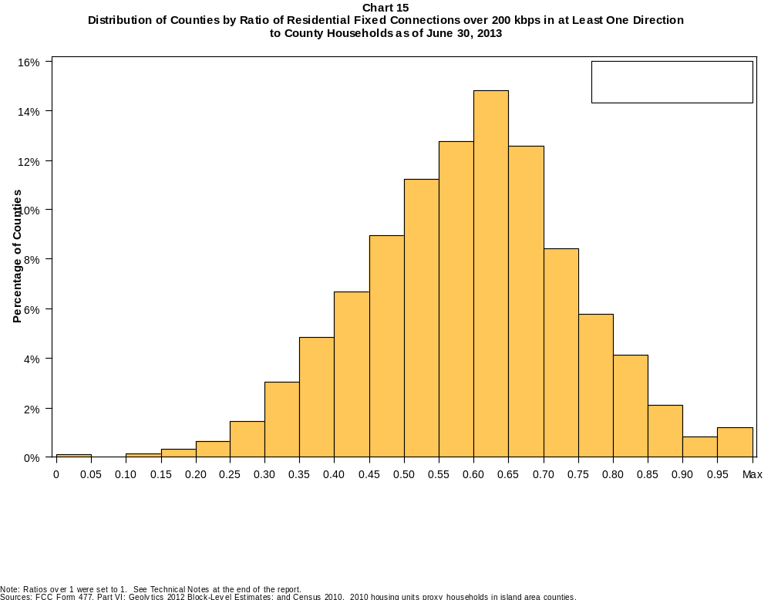

Table 22
Distribution of Counties by Ratio of Residential Fixed Connections over 200 kbps in at Least One Direction
to County Households by Technology as of June 30, 2013

 | Ratio of Residential Fixed Connections to County Households
Technology | Zero | Greater than 0 and no more than 5% | Greater than 5 and no more than 10% | Greater than 10 and no more than 20% | Greater than 20 and no more than 30% | Greater than 30 and no more than 40% | Greater than 40 and no more than 50% | Greater than 50 and no more than 60% | Greater than 60 and no more than 80% | Greater than 80 and no more than 100% | 100% or more
aDSL | 0.4 | 2.4 | 5.8 | 26.1 | 30.4 | 20.5 | 8.9 | 3.8 | 1.3 | 0.3 | 0.1
sDSL | 82.3 | 17.2 | 0.3 | 0.1 | 0.1 | 0.0 | 0.0 | 0.0 | 0.0 | 0.0 | 0.0
Other Wireline | 97.1 | 2.8 | 0.0 | 0.0 | 0.0 | 0.0 | 0.0 | 0.0 | 0.0 | 0.0 | 0.0
Cable Modem | 12.5 | 8.8 | 8.7 | 17.9 | 16.3 | 15.0 | 11.8 | 5.6 | 3.0 | 0.2 | 0.2
FTTP | 53.3 | 31.2 | 5.0 | 4.3 | 2.8 | 1.5 | 1.0 | 0.4 | 0.4 | 0.1 | 0.0
Satellite | 0.6 | 73.5 | 19.3 | 6.0 | 0.5 | 0.0 | 0.0 | 0.0 | 0.0 | 0.0 | 0.0
Fixed Wireless | 39.7 | 46.5 | 8.4 | 4.5 | 0.6 | 0.2 | 0.1 | 0.1 | 0.0 | 0.0 | 0.0
Power Line | 100.0 | 0.0 | 0.0 | 0.0 | 0.0 | 0.0 | 0.0 | 0.0 | 0.0 | 0.0 | 0.0
All Other | 100.0 | 0.0 | 0.0 | 0.0 | 0.0 | 0.0 | 0.0 | 0.0 | 0.0 | 0.0 | 0.0
Total | 0.1 | 0.0 | 0.0 | 0.5 | 2.1 | 7.9 | 15.6 | 24.0 | 41.6 | 7.4 | 0.9

Note: Figures may not sum to totals due to rounding. See Technical Notes at the end of the report.
Sources: FCC Form 477, Part VI; Geolytics 2012 Block-Level Estimates; and Census 2010. 2010 housing units proxy households in island area counties.

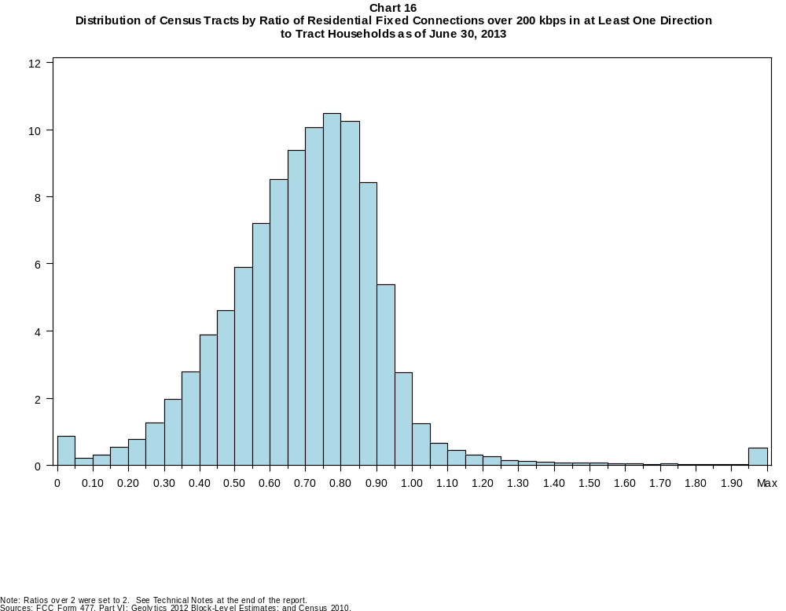

Table 23
Distribution of Census Tracts by Ratio of Residential Fixed Connections over 200 kbps in at Least One Direction
to Tract Households by Technology as of June 30, 2013

 | Ratio of Residential Fixed Connections to Tract Households
Technology | Zero | Greater than 0 and no more than 5% | Greater than 5 and no more than 10% | Greater than 10 and no more than 20% | Greater than 20 and no more than 30% | Greater than 30 and no more than 40% | Greater than 40 and no more than 50% | Greater than 50 and no more than 60% | Greater than 60 and no more than 80% | Greater than 80 and no more than 100% | 100% or more
aDSL | 1.4 | 9.8 | 11.4 | 27.4 | 23.4 | 14.8 | 7.0 | 2.7 | 1.3 | 0.3 | 0.3
sDSL | 96.6 | 3.2 | 0.1 | 0.1 | 0.0 | 0.0 | 0.0 | 0.0 | 0.0 | 0.0 | 0.0
Other Wireline | 99.7 | 0.2 | 0.0 | 0.0 | 0.0 | 0.0 | 0.0 | 0.0 | 0.0 | 0.0 | 0.0
Cable Modem | 5.6 | 3.3 | 2.4 | 7.2 | 13.8 | 18.5 | 18.3 | 14.6 | 13.2 | 2.2 | 1.0
FTTP | 71.2 | 11.5 | 2.1 | 3.0 | 3.1 | 3.8 | 2.9 | 1.6 | 0.8 | 0.1 | 0.1
Satellite | 30.2 | 61.8 | 4.7 | 2.5 | 0.5 | 0.1 | 0.0 | 0.0 | 0.0 | 0.0 | 0.0
Fixed Wireless | 82.3 | 13.7 | 1.9 | 1.4 | 0.4 | 0.2 | 0.1 | 0.0 | 0.0 | 0.0 | 0.0
Power Line | 100.0 | 0.0 | 0.0 | 0.0 | 0.0 | 0.0 | 0.0 | 0.0 | 0.0 | 0.0 | 0.0
All Other | 100.0 | 0.0 | 0.0 | 0.0 | 0.0 | 0.0 | 0.0 | 0.0 | 0.0 | 0.0 | 0.0
Total | 0.7 | 0.1 | 0.2 | 0.9 | 2.1 | 4.8 | 8.5 | 13.1 | 38.4 | 26.8 | 4.3

Note: Figures may not sum to totals due to rounding. See Technical Notes at the end of the report.
Sources: FCC Form 477, Part VI; Geolytics 2012 Block-Level Estimates; and Census 2010.

Table 24
Percentage of Census Tracts with Residential Fixed Connections by Technology as of June 30, 2013
(Connections over 200 kbps in at least one direction)

 | Number of Providers
Technology | Zero | One | Two | Three | Four | Five | Six | Seven or More
aDSL | 1.4 | 53.5 | 33.6 | 10.0 | 1.3 | 0.1 | 0.0 | 0.0
sDSL | 96.6 | 3.2 | 0.1 | 0.0 | 0.0 | 0.0 | 0.0 | 0.0
Other Wireline | 99.7 | 0.3 | 0.0 | 0.0 | 0.0 | 0.0 | 0.0 | 0.0
Cable Modem | 5.6 | 81.4 | 12.4 | 0.5 | 0.0 | 0.0 | 0.0 | 0.0
FTTP | 71.2 | 28.0 | 0.7 | 0.1 | 0.0 | 0.0 | 0.0 | 0.0
Satellite | 30.2 | 23.6 | 44.3 | 1.9 | 0.0 | 0.0 | 0.0 | 0.0
Fixed Wireless | 82.3 | 12.8 | 3.6 | 1.0 | 0.2 | 0.0 | 0.0 | 0.0
Power Line | 100.0 | 0.0 | 0.0 | 0.0 | 0.0 | 0.0 | 0.0 | 0.0
aDSL and/or Cable Modem and/or FTTP | 0.9 | 2.8 | 45.7 | 34.0 | 13.4 | 2.6 | 0.4 | 0.1
Any Technology | 0.7 | 0.4 | 12.7 | 22.1 | 29.2 | 20.1 | 9.3 | 5.3

Note: Figures may not sum to totals due to rounding. The number of providers in a census tract does not necessarily reflect the number of choices available to a particular household, and does not purport
to measure competition.
Sources: FCC Form 477, Part VI and Census 2010.

Table 25
Distribution of Counties by Ratio of Residential Fixed Connections to County Households by State as of June 30, 2013
(Connections over 200 kbps in at least one direction)

 |  | Ratio of Residential Fixed Connections over 200 kbps in at Least One Direction to County Households
State | Counties | Zero | Greater than 0 and no more than 5% | Greater than 5 and no more than 10% | Greater than 10 and no more than 20% | Greater than 20 and no more than 30% | Greater than 30 and no more than 40% | Greater than 40 and no more than 50% | Greater than 50 and no more than 60% | Greater than 60 and no more than 80% | Greater than 80 and no more than 100% | 100% or more
Alabama | 67 | 0 | 0 | 0 | 0 | 3 | 9 | 22 | 16 | 17 | 0 | 0
Alaska | 29 | 0 | 0 | 0 | 1 | 2 | 1 | 6 | 3 | 15 | 0 | 1
American Samoa | 5 | 2 | 1 | 0 | 1 | 0 | 1 | 0 | 0 | 0 | 0 | 0
Arizona | 15 | 0 | 0 | 0 | 0 | 0 | 2 | 0 | 5 | 8 | 0 | 0
Arkansas | 75 | 0 | 0 | 0 | 0 | 2 | 17 | 34 | 13 | 9 | 0 | 0
California | 58 | 0 | 0 | 0 | 1 | 0 | 1 | 2 | 9 | 33 | 11 | 1
Colorado | 64 | 0 | 0 | 0 | 0 | 1 | 2 | 6 | 12 | 22 | 14 | 7
Connecticut | 8 | 0 | 0 | 0 | 0 | 0 | 0 | 0 | 0 | 4 | 4 | 0
Delaware | 3 | 0 | 0 | 0 | 0 | 0 | 0 | 0 | 0 | 1 | 2 | 0
District of Columbia | 1 | 0 | 0 | 0 | 0 | 0 | 0 | 0 | 0 | 1 | 0 | 0
Florida | 67 | 0 | 0 | 0 | 0 | 1 | 2 | 10 | 11 | 33 | 9 | 1
Georgia | 159 | 0 | 0 | 0 | 1 | 7 | 16 | 38 | 33 | 54 | 10 | 0
Guam | 1 | 0 | 0 | 0 | 0 | 0 | 0 | 0 | 0 | 1 | 0 | 0
Hawaii | 5 | 0 | 0 | 0 | 0 | 0 | 0 | 0 | 0 | 2 | 3 | 0
Idaho | 44 | 0 | 0 | 0 | 0 | 2 | 0 | 6 | 10 | 23 | 2 | 1
Illinois | 102 | 0 | 0 | 0 | 1 | 2 | 3 | 13 | 35 | 41 | 4 | 3
Indiana | 92 | 0 | 0 | 0 | 0 | 0 | 3 | 17 | 34 | 36 | 2 | 0
Iowa | 99 | 0 | 0 | 0 | 0 | 0 | 0 | 3 | 26 | 68 | 2 | 0
Kansas | 105 | 0 | 0 | 0 | 0 | 0 | 1 | 12 | 29 | 52 | 11 | 0
Kentucky | 120 | 0 | 0 | 0 | 0 | 2 | 5 | 24 | 42 | 45 | 2 | 0
Louisiana | 64 | 0 | 0 | 0 | 0 | 1 | 10 | 14 | 17 | 22 | 0 | 0
Maine | 16 | 0 | 0 | 0 | 0 | 0 | 0 | 0 | 2 | 9 | 5 | 0
Maryland | 24 | 0 | 0 | 0 | 2 | 0 | 0 | 2 | 1 | 13 | 5 | 1
Massachusetts | 14 | 0 | 0 | 0 | 0 | 0 | 0 | 0 | 0 | 7 | 4 | 3
Michigan | 83 | 0 | 0 | 0 | 0 | 0 | 8 | 5 | 32 | 35 | 3 | 0
Minnesota | 87 | 0 | 0 | 0 | 0 | 0 | 1 | 2 | 17 | 63 | 4 | 0
Mississippi | 82 | 0 | 0 | 0 | 0 | 10 | 36 | 18 | 10 | 8 | 0 | 0
Missouri | 115 | 0 | 0 | 0 | 1 | 2 | 8 | 34 | 41 | 27 | 2 | 0
Montana | 56 | 0 | 0 | 0 | 0 | 1 | 0 | 6 | 12 | 33 | 4 | 0
Nebraska | 93 | 0 | 0 | 0 | 0 | 0 | 4 | 6 | 28 | 54 | 1 | 0

Table 25 - Continued
Distribution of Counties by Ratio of Residential Fixed Connections to County Households by State as of June 30, 2013
(Connections over 200 kbps in at least one direction)

 |  | Ratio of Residential Fixed Connections over 200 kbps in at Least One Direction to County Households
State | Counties | Zero | Greater than 0 and no more than 5% | Greater than 5 and no more than 10% | Greater than 10 and no more than 20% | Greater than 20 and no more than 30% | Greater than 30 and no more than 40% | Greater than 40 and no more than 50% | Greater than 50 and no more than 60% | Greater than 60 and no more than 80% | Greater than 80 and no more than 100% | 100% or more
Nevada | 17 | 0 | 0 | 0 | 0 | 0 | 4 | 3 | 3 | 7 | 0 | 0
New Hampshire | 10 | 0 | 0 | 0 | 0 | 0 | 0 | 0 | 0 | 4 | 5 | 1
New Jersey | 21 | 0 | 0 | 0 | 0 | 0 | 0 | 0 | 0 | 6 | 14 | 1
New Mexico | 33 | 0 | 0 | 0 | 0 | 1 | 6 | 5 | 10 | 9 | 2 | 0
New York | 62 | 0 | 0 | 0 | 0 | 0 | 0 | 0 | 2 | 43 | 16 | 1
North Carolina | 100 | 0 | 0 | 0 | 0 | 0 | 2 | 19 | 21 | 43 | 13 | 2
North Dakota | 53 | 0 | 0 | 0 | 0 | 0 | 0 | 4 | 6 | 36 | 7 | 0
Northern Mariana Isl | 4 | 1 | 0 | 0 | 0 | 3 | 0 | 0 | 0 | 0 | 0 | 0
Ohio | 88 | 0 | 0 | 0 | 1 | 0 | 1 | 7 | 23 | 52 | 4 | 0
Oklahoma | 77 | 0 | 0 | 0 | 0 | 2 | 17 | 22 | 19 | 16 | 1 | 0
Oregon | 36 | 0 | 0 | 0 | 0 | 0 | 2 | 0 | 10 | 21 | 3 | 0
Pennsylvania | 67 | 0 | 0 | 0 | 0 | 0 | 1 | 1 | 11 | 40 | 13 | 1
Puerto Rico | 78 | 0 | 0 | 0 | 0 | 10 | 18 | 34 | 13 | 3 | 0 | 0
Rhode Island | 5 | 0 | 0 | 0 | 0 | 0 | 0 | 0 | 0 | 3 | 2 | 0
South Carolina | 46 | 0 | 0 | 0 | 0 | 0 | 7 | 10 | 13 | 11 | 5 | 0
South Dakota | 66 | 0 | 0 | 0 | 0 | 1 | 2 | 4 | 7 | 47 | 5 | 0
Tennessee | 95 | 0 | 0 | 0 | 1 | 2 | 9 | 31 | 32 | 19 | 1 | 0
Texas | 254 | 0 | 0 | 0 | 1 | 5 | 29 | 58 | 81 | 69 | 8 | 3
Utah | 29 | 0 | 0 | 0 | 0 | 1 | 1 | 1 | 5 | 15 | 5 | 1
Vermont | 14 | 0 | 0 | 0 | 0 | 0 | 0 | 0 | 1 | 7 | 6 | 0
Virgin Islands | 3 | 0 | 0 | 0 | 0 | 0 | 1 | 1 | 0 | 1 | 0 | 0
Virginia | 134 | 0 | 0 | 0 | 4 | 7 | 18 | 14 | 39 | 35 | 17 | 0
Washington | 39 | 0 | 0 | 0 | 0 | 0 | 2 | 1 | 6 | 27 | 3 | 0
West Virginia | 55 | 0 | 0 | 0 | 0 | 0 | 3 | 8 | 19 | 24 | 1 | 0
Wisconsin | 72 | 0 | 0 | 0 | 0 | 0 | 0 | 1 | 13 | 54 | 4 | 0
Wyoming | 23 | 0 | 0 | 0 | 0 | 0 | 1 | 2 | 4 | 16 | 0 | 0
Total | 3,234 | 3 | 1 | 0 | 15 | 68 | 254 | 506 | 776 | 1344 | 239 | 28

Note: Figures may not sum to totals due to rounding. See Technical Notes at the end of the report.
Sources: FCC Form 477, Part VI (Connections); Geolytics 2012 Block-Level Estimates (Households for U.S. and District of Columbia); Census 2010 (Housing units for Puerto Rico, American Samoa,
Guam, Northern Mariana Islands and U.S. Virgin Islands).

Table 26
Distribution of Census Tracts by Ratio of Residential Fixed Connections to Tract Households by State as of June 30, 2013
(Connections over 200 kbps in at least one direction)

 |  | Ratio of Residential Fixed Connections over 200 kbps in at Least One Direction to Tract Households
State | Tracts | Zero | Greater than 0 and no more than 5% | Greater than 5 and no more than 10% | Greater than 10 and no more than 20% | Greater than 20 and no more than 30% | Greater than 30 and no more than 40% | Greater than 40 and no more than 50% | Greater than 50 and no more than 60% | Greater than 60 and no more than 80% | Greater than 80 and no more than 100% | 100% or more
Alabama | 1,179 | 5 | 2 | 1 | 14 | 73 | 151 | 229 | 217 | 342 | 123 | 22
Alaska | 167 | 1 | 0 | 1 | 4 | 7 | 7 | 14 | 26 | 76 | 19 | 12
American Samoa | 18 | 3 | 5 | 2 | 1 | 2 | 0 | 3 | 0 | 1 | 0 | 1
Arizona | 1,526 | 18 | 7 | 10 | 18 | 21 | 60 | 119 | 210 | 541 | 454 | 68
Arkansas | 686 | 2 | 1 | 1 | 11 | 54 | 107 | 161 | 133 | 161 | 43 | 12
California | 8,036 | 51 | 8 | 12 | 33 | 71 | 164 | 398 | 752 | 3,071 | 3,192 | 284
Colorado | 1,249 | 13 | 1 | 1 | 2 | 8 | 19 | 50 | 110 | 489 | 467 | 89
Connecticut | 829 | 3 | 0 | 0 | 0 | 2 | 9 | 34 | 58 | 283 | 420 | 20
Delaware | 215 | 1 | 0 | 0 | 0 | 1 | 0 | 11 | 22 | 75 | 83 | 22
District of Columbia | 179 | 1 | 0 | 0 | 0 | 0 | 2 | 11 | 28 | 75 | 48 | 14
Florida | 4,199 | 37 | 2 | 2 | 6 | 26 | 94 | 265 | 526 | 1,822 | 1,173 | 246
Georgia | 1,964 | 10 | 2 | 4 | 12 | 65 | 143 | 241 | 312 | 688 | 417 | 70
Guam | 56 | 6 | 0 | 1 | 3 | 4 | 6 | 4 | 4 | 6 | 4 | 18
Hawaii | 326 | 11 | 0 | 1 | 2 | 0 | 3 | 4 | 19 | 125 | 120 | 41
Idaho | 298 | 0 | 0 | 1 | 1 | 4 | 11 | 19 | 61 | 159 | 34 | 8
Illinois | 3,121 | 9 | 3 | 3 | 14 | 34 | 153 | 331 | 503 | 1,353 | 663 | 55
Indiana | 1,508 | 5 | 2 | 1 | 3 | 20 | 55 | 207 | 370 | 632 | 200 | 13
Iowa | 825 | 2 | 1 | 0 | 0 | 4 | 12 | 52 | 160 | 498 | 85 | 11
Kansas | 770 | 9 | 0 | 1 | 3 | 10 | 37 | 71 | 167 | 309 | 131 | 32
Kentucky | 1,115 | 11 | 0 | 1 | 10 | 24 | 59 | 139 | 246 | 434 | 168 | 23
Louisiana | 1,136 | 14 | 0 | 1 | 4 | 28 | 105 | 184 | 220 | 434 | 124 | 22
Maine | 351 | 0 | 0 | 0 | 0 | 1 | 4 | 15 | 39 | 174 | 83 | 35
Maryland | 1,394 | 7 | 1 | 3 | 17 | 15 | 61 | 83 | 110 | 446 | 574 | 77
Massachusetts | 1,471 | 12 | 0 | 1 | 1 | 2 | 6 | 16 | 83 | 499 | 752 | 99
Michigan | 2,767 | 30 | 3 | 5 | 16 | 80 | 221 | 288 | 362 | 1,104 | 627 | 31
Minnesota | 1,335 | 4 | 2 | 0 | 3 | 7 | 13 | 66 | 198 | 698 | 330 | 14
Mississippi | 661 | 4 | 0 | 0 | 13 | 72 | 148 | 133 | 104 | 143 | 35 | 9
Missouri | 1,393 | 6 | 1 | 2 | 12 | 55 | 129 | 182 | 298 | 466 | 213 | 29
Montana | 271 | 2 | 0 | 3 | 2 | 2 | 8 | 18 | 52 | 135 | 40 | 9
Nebraska | 532 | 2 | 0 | 0 | 0 | 0 | 13 | 40 | 91 | 253 | 114 | 19

Table 26 - Continued
Distribution of Census Tracts by Ratio of Residential Fixed Connections to Tract Households by State as of June 30, 2013
(Connections over 200 kbps in at least one direction)

 |  | Ratio of Residential Fixed Connections over 200 kbps in at Least One Direction to Tract Households
State | Tracts | Zero | Greater than 0 and no more than 5% | Greater than 5 and no more than 10% | Greater than 10 and no more than 20% | Greater than 20 and no more than 30% | Greater than 30 and no more than 40% | Greater than 40 and no more than 50% | Greater than 50 and no more than 60% | Greater than 60 and no more than 80% | Greater than 80 and no more than 100% | 100% or more
Nevada | 683 | 6 | 0 | 0 | 9 | 12 | 31 | 68 | 76 | 290 | 161 | 30
New Hampshire | 294 | 2 | 0 | 0 | 1 | 0 | 0 | 1 | 7 | 102 | 161 | 20
New Jersey | 2,004 | 9 | 1 | 0 | 1 | 0 | 5 | 19 | 76 | 690 | 1,088 | 115
New Mexico | 499 | 4 | 9 | 5 | 8 | 20 | 41 | 75 | 98 | 171 | 53 | 15
New York | 4,900 | 73 | 0 | 3 | 19 | 20 | 54 | 130 | 276 | 2,084 | 1,918 | 323
North Carolina | 2,183 | 19 | 2 | 1 | 4 | 34 | 102 | 231 | 353 | 712 | 459 | 266
North Dakota | 205 | 0 | 0 | 0 | 0 | 0 | 7 | 11 | 27 | 108 | 42 | 10
Northern Mariana Isl | 22 | 3 | 2 | 0 | 6 | 7 | 0 | 1 | 2 | 0 | 1 | 0
Ohio | 2,946 | 7 | 10 | 27 | 78 | 64 | 141 | 266 | 434 | 1,214 | 600 | 105
Oklahoma | 1,046 | 1 | 4 | 4 | 30 | 65 | 122 | 184 | 174 | 286 | 140 | 36
Oregon | 827 | 2 | 0 | 0 | 2 | 1 | 9 | 24 | 107 | 469 | 197 | 16
Pennsylvania | 3,217 | 21 | 2 | 2 | 17 | 27 | 45 | 154 | 408 | 1,456 | 908 | 177
Puerto Rico | 903 | 16 | 4 | 13 | 114 | 145 | 172 | 144 | 96 | 107 | 40 | 52
Rhode Island | 241 | 1 | 0 | 0 | 1 | 0 | 0 | 2 | 13 | 130 | 86 | 8
South Carolina | 1,097 | 10 | 0 | 0 | 6 | 37 | 93 | 172 | 170 | 332 | 189 | 88
South Dakota | 222 | 0 | 1 | 0 | 1 | 1 | 9 | 8 | 30 | 133 | 34 | 5
Tennessee | 1,497 | 22 | 2 | 1 | 12 | 60 | 153 | 266 | 310 | 459 | 181 | 31
Texas | 5,253 | 39 | 1 | 25 | 65 | 222 | 522 | 767 | 772 | 1,559 | 978 | 303
Utah | 588 | 5 | 2 | 3 | 1 | 3 | 3 | 17 | 56 | 277 | 195 | 26
Vermont | 184 | 1 | 0 | 0 | 0 | 0 | 1 | 1 | 10 | 91 | 66 | 14
Virgin Islands | 29 | 0 | 0 | 1 | 4 | 5 | 6 | 4 | 5 | 3 | 0 | 1
Virginia | 1,895 | 22 | 1 | 9 | 34 | 64 | 95 | 148 | 230 | 484 | 712 | 96
Washington | 1,446 | 2 | 1 | 3 | 4 | 11 | 22 | 55 | 108 | 674 | 542 | 24
West Virginia | 484 | 0 | 1 | 2 | 13 | 17 | 31 | 52 | 94 | 189 | 65 | 20
Wisconsin | 1,393 | 3 | 2 | 0 | 5 | 8 | 60 | 96 | 223 | 748 | 229 | 19
Wyoming | 132 | 1 | 0 | 0 | 0 | 4 | 4 | 11 | 17 | 73 | 22 | 0
Total | 73,767 | 548 | 86 | 157 | 640 | 1,519 | 3,528 | 6,295 | 9,653 | 28,333 | 19,803 | 3,205

Note: Figures may not sum to totals due to rounding. See Technical Notes at the end of the report.
Sources: FCC Form 477, Part VI (Connections); Geolytics 2012 Block-Level Estimates (Households for U.S. and District of Columbia); Census 2010 (Households for Puerto Rico, American Samoa,
Guam, Northern Mariana Islands and U.S. Virgin Islands).

